# Part I. Demographics

|  |  |  |  |  |  |
| --- | --- | --- | --- | --- | --- |
| **Table S1**. Basic demographic description of the sample of the participants (raters) | | | | | |
| Culture | Number part's | Of it females/males | Age [yrs] | Height [cm] | Weight [kg] |
| Australia + New Zeal. | 53 | 28 / 24 | 34.51 ± 12.62 | 169.57 ± 8.94 | 73.81 ± 20.77 |
| Colombia | 16 | 8 / 8 | 30.12 ± 12.95 | 164.2 ± 9.54 | 61.81 ± 10.26 |
| Czech Republic | 152 | 119 / 32 | 35.94 ± 10.13 | 170.3 ± 8.23 | 72.24 ± 16.97 |
| South Africa | 47 | 32 /15 | 25.62 ± 4.28 | 165.66 ± 10.11 | 80.18 ± 24.86 |
| Turkey | 79 | 63 / 15 | 22.15 ± 3.03 | 168.79 ± 7.88 | 63.24 ± 14.88 |
| Vietnam | 72 | 42 / 28 | 26.36 ± 7.46 | 163.78 ± 9.4 | 60.26 ± 11.35 |

|  |  |  |  |  |
| --- | --- | --- | --- | --- |
| **Table S2**. Basic demographic description of the sample of the female participants (raters) | | | | |
| Culture | Number part’s | Age | Height | Weight |
| Australia + New Zealand | 28 | 35.29 ± 14.84 | 165.96 ± 7.93 | 70.39 ± 25.52 |
| Colombia | 8 | 28.5 ± 11.12 | 146.62 ± 27.55 | 55 ± 7.39 |
| CZech Republic | 119 | 35.97 ± 10.21 | 167.51 ± 5.91 | 68.41± 15.19 |
| South Africa | 32 | 26.12 ± 4.55 | 153.03 ± 31.74 | 79.38 ± 26.92 |
| Turkey | 63 | 22.33 ± 3.25 | 156.15 ± 27.87 | 59.43 ± 11.45 |
| Vietnam | 42 | 25.9 ± 7.8 | 155.88 ± 13.18 | 53.36 ± 7.39 |

|  |  |  |  |  |
| --- | --- | --- | --- | --- |
| **Table S3.** Basic demographic description of the sample of the male participants (raters) | | | | |
| Culture | Number part’s | Age [yrs] | Height [cm] | Weight [kg] |
| Australia + New Zealand | 24 | 33.33 ± 9.88 | 174.04 ± 8.27 | 77.54 ± 13.41 |
| Colombia | 8 | 31.75 ± 15.14 | 171.25 ± 5.12 | 68.62 ± 8.05 |
| CZech Republic | 32 | 36.31 ± 9.8 | 180.56 ± 7.63 | 86.47 ± 16.13 |
| South Africa | 15 | 24.53 ± 3.54 | 174.33 - 7.29 | 81.87 ± 20.52 |
| Turkey | 15 | 21.27 ± 1.79 | 178.6 ± 6.31 | 75.87 ± 15.97 |
| Vietnam | 28 | 26.54 ± 6.82 | 173.43 ± 27.82 | 68.43 ± 6.71 |

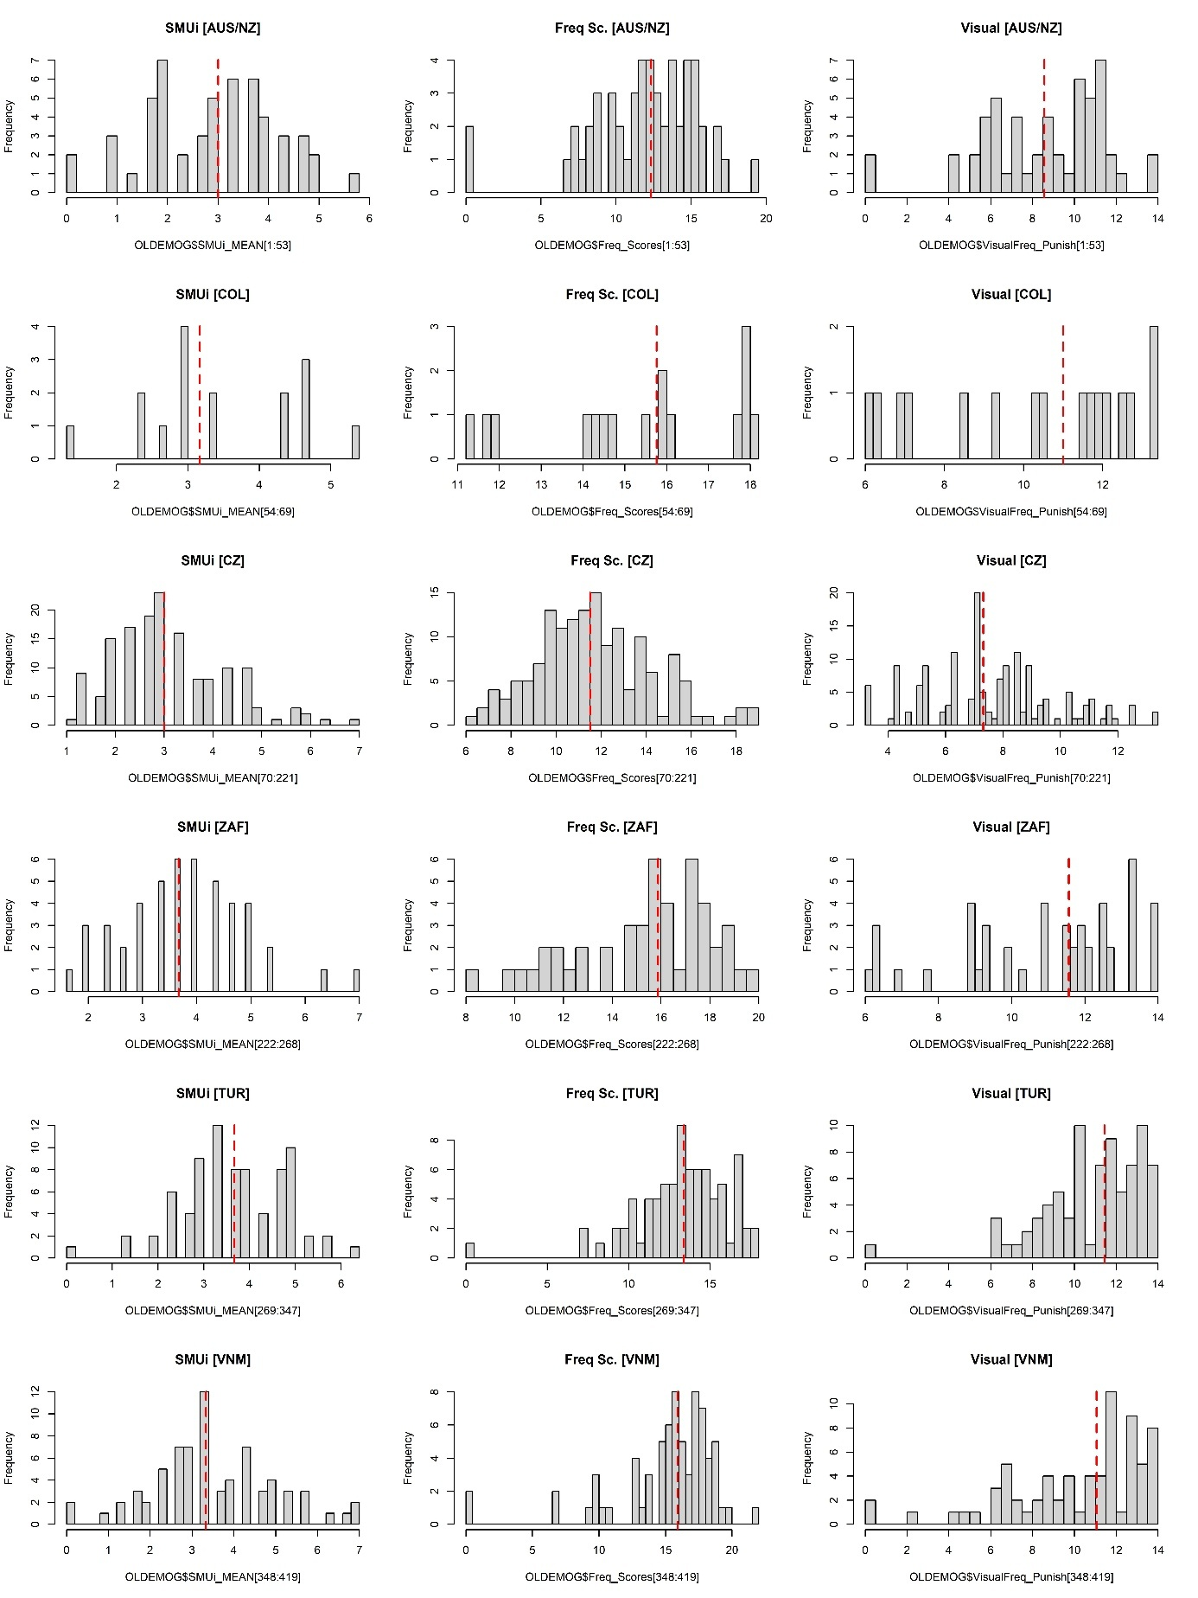

**Figure S1**. Distribution of SMUi (*General social media use intensity*), Freq Sc. (*Punished Score of specific social media use intensity, PS-SMU-i*) and *Visual Media Score*. Dashed red vertical lines correspond to median of the distribution.

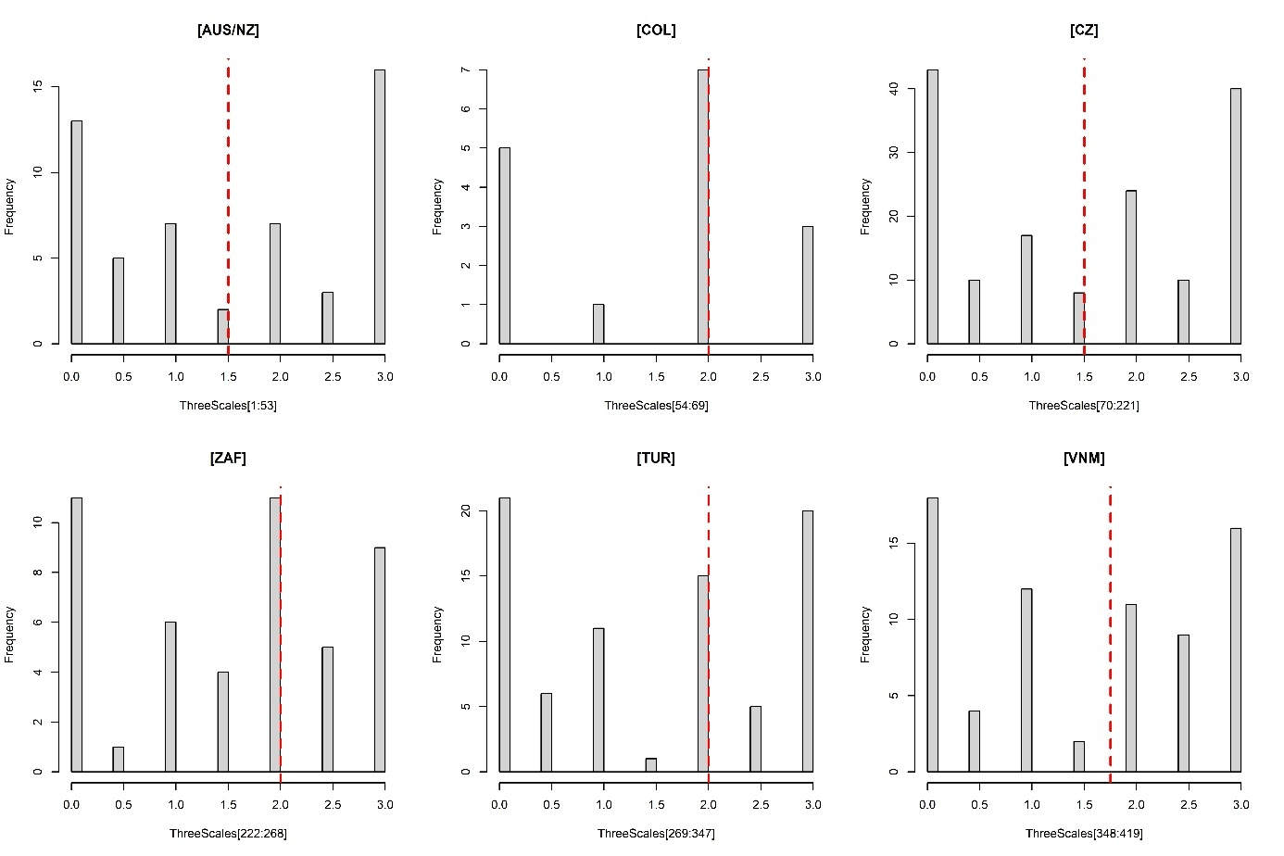

**Figure S2**. Distribution above median (1), median (0.5) and below median scores (0) on the selected scales per participant, summed across the three scales above. Dashed red vertical lines correspond to median of the distribution.

# Part II. YUFE – rating study, results:

Attr = Rated attractiveness  
Dom = Rated dominance   
Trustw = Rated trustworthiness

GMM = Geometric Morphometrics

## Part 1: ATTR/TRUSTW/DOM: NO-GMM

**“Zero stage”**: Predictions based on the models with just one response variable: Either attractiveness or trustworthiness.

(a) Model with varying term on the level of faces:

Attr_long_F <- ulam(alist(

# Multivariate normal for Attractiveness

AtrRating ~ normal(muA, sigma_A),

# Mean structure for Attractiveness

muA <- z_rNV_A[rater] * sigma_rater_A

+ **f_per_group_A[face, FSMUi]** # per face - per culture

+ (aA + f_per_group_pr_A[FSMUi,1])

+ (b_age_A + f_per_group_pr_A[FSMUi, 2]) * Age

+ (b_dist_A + f_per_group_pr_A[FSMUi, 3]) * dist

+ (b_FA_A + f_per_group_pr_A[FSMUi, 4]) * FA

+ (b_sshd_A + f_per_group_pr_A[FSMUi, 5]) * sshd

+ (b_L_A + f_per_group_pr_A[FSMUi,6]) * L,

# Priors for Attractiveness intercept

aA ~ dnorm(0, 0.5), # Attractiveness

# Priors for Attractiveness and slopes

b_age_A ~ dnorm(0, 0.3),

b_dist_A ~ dnorm(0, 0.3),

b_FA_A ~ dnorm(0, 0.3),

b_sshd_A ~ dnorm(0, 0.3),

b_L_A ~ dnorm(0, 0.3),

# Non-centered parameterization for rater effects

z_rNV_A[rater] ~ dnorm(0, 1), # Attractiveness latent variable

sigma_rater_A ~ dexp(1), # Attractiveness

gq> vector[rater]:a_rNV_A <<- aA + z_rNV_A * sigma_rater_A, # Generate rater effects for Attractiveness

# Varying effects for Attractiveness morpho-predictors

transpars> matrix[FSMUi, 6]:f_per_group_pr_A <- compose_noncentered(sigma_pr_A, L_Rho_pr_A, z_pr_A),

cholesky_factor_corr[6]:L_Rho_pr_A ~ lkj_corr_cholesky(2),

matrix[6, FSMUi]:z_pr_A ~ normal(0, 1),

vector[6]:sigma_pr_A ~ dexp(1),

gq> matrix[6, 6]:Rho_pr_A <<- Chol_to_Corr(L_Rho_pr_A),

**# Priors for the multivariate normal distribution for face intercepts across groups**

**transpars> matrix[face, 12]:f_per_group_A <- compose_noncentered(sigma_FSMUi_A, L_Rho_FSMUi_A, z_FSMUi_A),**

**cholesky_factor_corr[12]:L_Rho_FSMUi_A ~ lkj_corr_cholesky(2),**

**matrix[12, face]:z_FSMUi_A ~ normal(0, 1),**

**vector[12]:sigma_FSMUi_A ~ dexp(1),**

**gq> matrix[12, 12]:Rho_FSMUi_A <<- Chol_to_Corr(L_Rho_FSMUi_A),**

sigma_A ~ dexp(1)

), data=D_AT_F, iter=1000, sample=T, cores=8, chains=8, log_lik=T)

We also run the same model with the parts in bold deleted. The two models were compared using WAIC.

The same models were also fitted for trustworthiness.

**WAIC – attractiveness**

**(F)**:

WAIC SE dWAIC dSE pWAIC weight

Attr_long_F 47627.5 246.28 0.0 NA 1016.4 1 (model with per-face term)

Attr_short_F 53534.1 235.48 5906.5 151.58 430.3 0

**(M):**

WAIC SE dWAIC dSE pWAIC weight

Attr_long_M 40561.0 228.93 0.0 NA 912.5 1 (model with per-face term)

Attr_short_M 45478.3 220.56 4917.4 137.7 418.5 0

**WAIC – trustworthiness**

**(F)**:

WAIC SE dWAIC dSE pWAIC weight

Trustw_long_F 53212.2 227.23 0.0 NA 939.9 1 (model with per-face term)

Trustw_short_F 55935.7 220.59 2723.5 106.03 424.1 0

**(M):**

WAIC SE dWAIC dSE pWAIC weight

Trustw_long_M 44849.0 204.05 0.0 NA 865.3 1 (model with per-face term)

Trustw_short_M 47440.3 195.52 2591.3 101.87 416.7 0

**WAIC – dominance**

**(F)**:

WAIC SE dWAIC dSE pWAIC weight

Dom_long_F 55582.6 219.14 0 NA 933.2 1 (model with per-face term)

Dom_short_F 57426.6 209.18 1844 90.53 414.7 0

**(M):**

WAIC SE dWAIC dSE pWAIC weight

Dom_long_M 46113.8 208.54 0 NA 860.3 1 (model with per-face term)

Dom_short_M 48327.8 197.16 2214 96.81 417.2 0

In all the cases, the models with varying terms for each face (estimating also the correlation between different groups’ ratings) had better out-of-sample predictive accuracy. Results of these models are reported below.

### Note: Problems experienced during posterior evaluation:

We used Intel® Core™ i9-12900K Processor for sampling from posterior (MCMC sampling using stan / cmdstan / cmdstanr infrastructure). When using full number of 16 cores and 16 chains, we experienced problems with one chain. The posterior was unequally distributed, with heavy tail towards negative values:

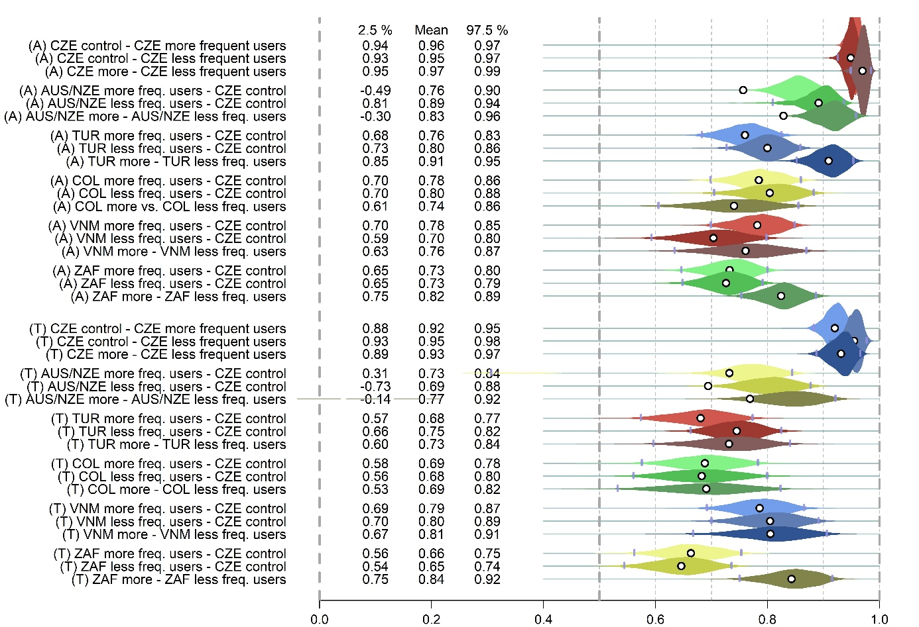

**Figure S3**. Suboptimal sampling from the posterior. Shown on posterior distributions, based on a preliminary version of the model.

This problem was experienced only when we assigned one chain to every core. We could only speculate what is the reason of such behaviour. Importantly, however, this issue was not experienced when we used smaller number of cores (14 for a 16-core CPU).

## Part 1.2. Models with attractiveness, trustworthiness, and dominance as the sole response variable: model predictions

In each model, there was just one dependent variable:   
Attractiveness, Trustworthiness, or Dominance. The purpose of these models was calculating WAIC and comparing more and less complex versions of the models (see above).

We shall also demonstrate that prediction of these three models do not differ substantially from the case when the three scales are in the same model (an instance when WAIC cannot be calculated in function ulam() of the package Rethinking and, notably, a situation when the WAIC, calculated based on the estimated parameters, may be unreliable.

In principle, as the Figures below suggest, predictions are nearly identical, whether we put all the three scales in a single model, or into three separate models.

### 1.2.1. Figure S1 - analogue of Figure 1 in the article “correlation heatmaps”

Figure S1A – Female stimuli



**Figure S4.** Posterior distributions of correlation coefficients: association between ratings in different samples (Freq = users above median in social media use frequency; Infreq = users below the median). Female stimuli. Predictions based on three separate models. NewZ in the upper panel = New Zealand. Abbreviations in the lower panel (CZE [Czechia], AUS/NZE [Australia/New Zealand], TUR [Turkey], COL [Colombia], VNM [Vietnam], ZAF [South Africa]) correspond to three-letter country codes (ISO 3166-1 alpha-3).

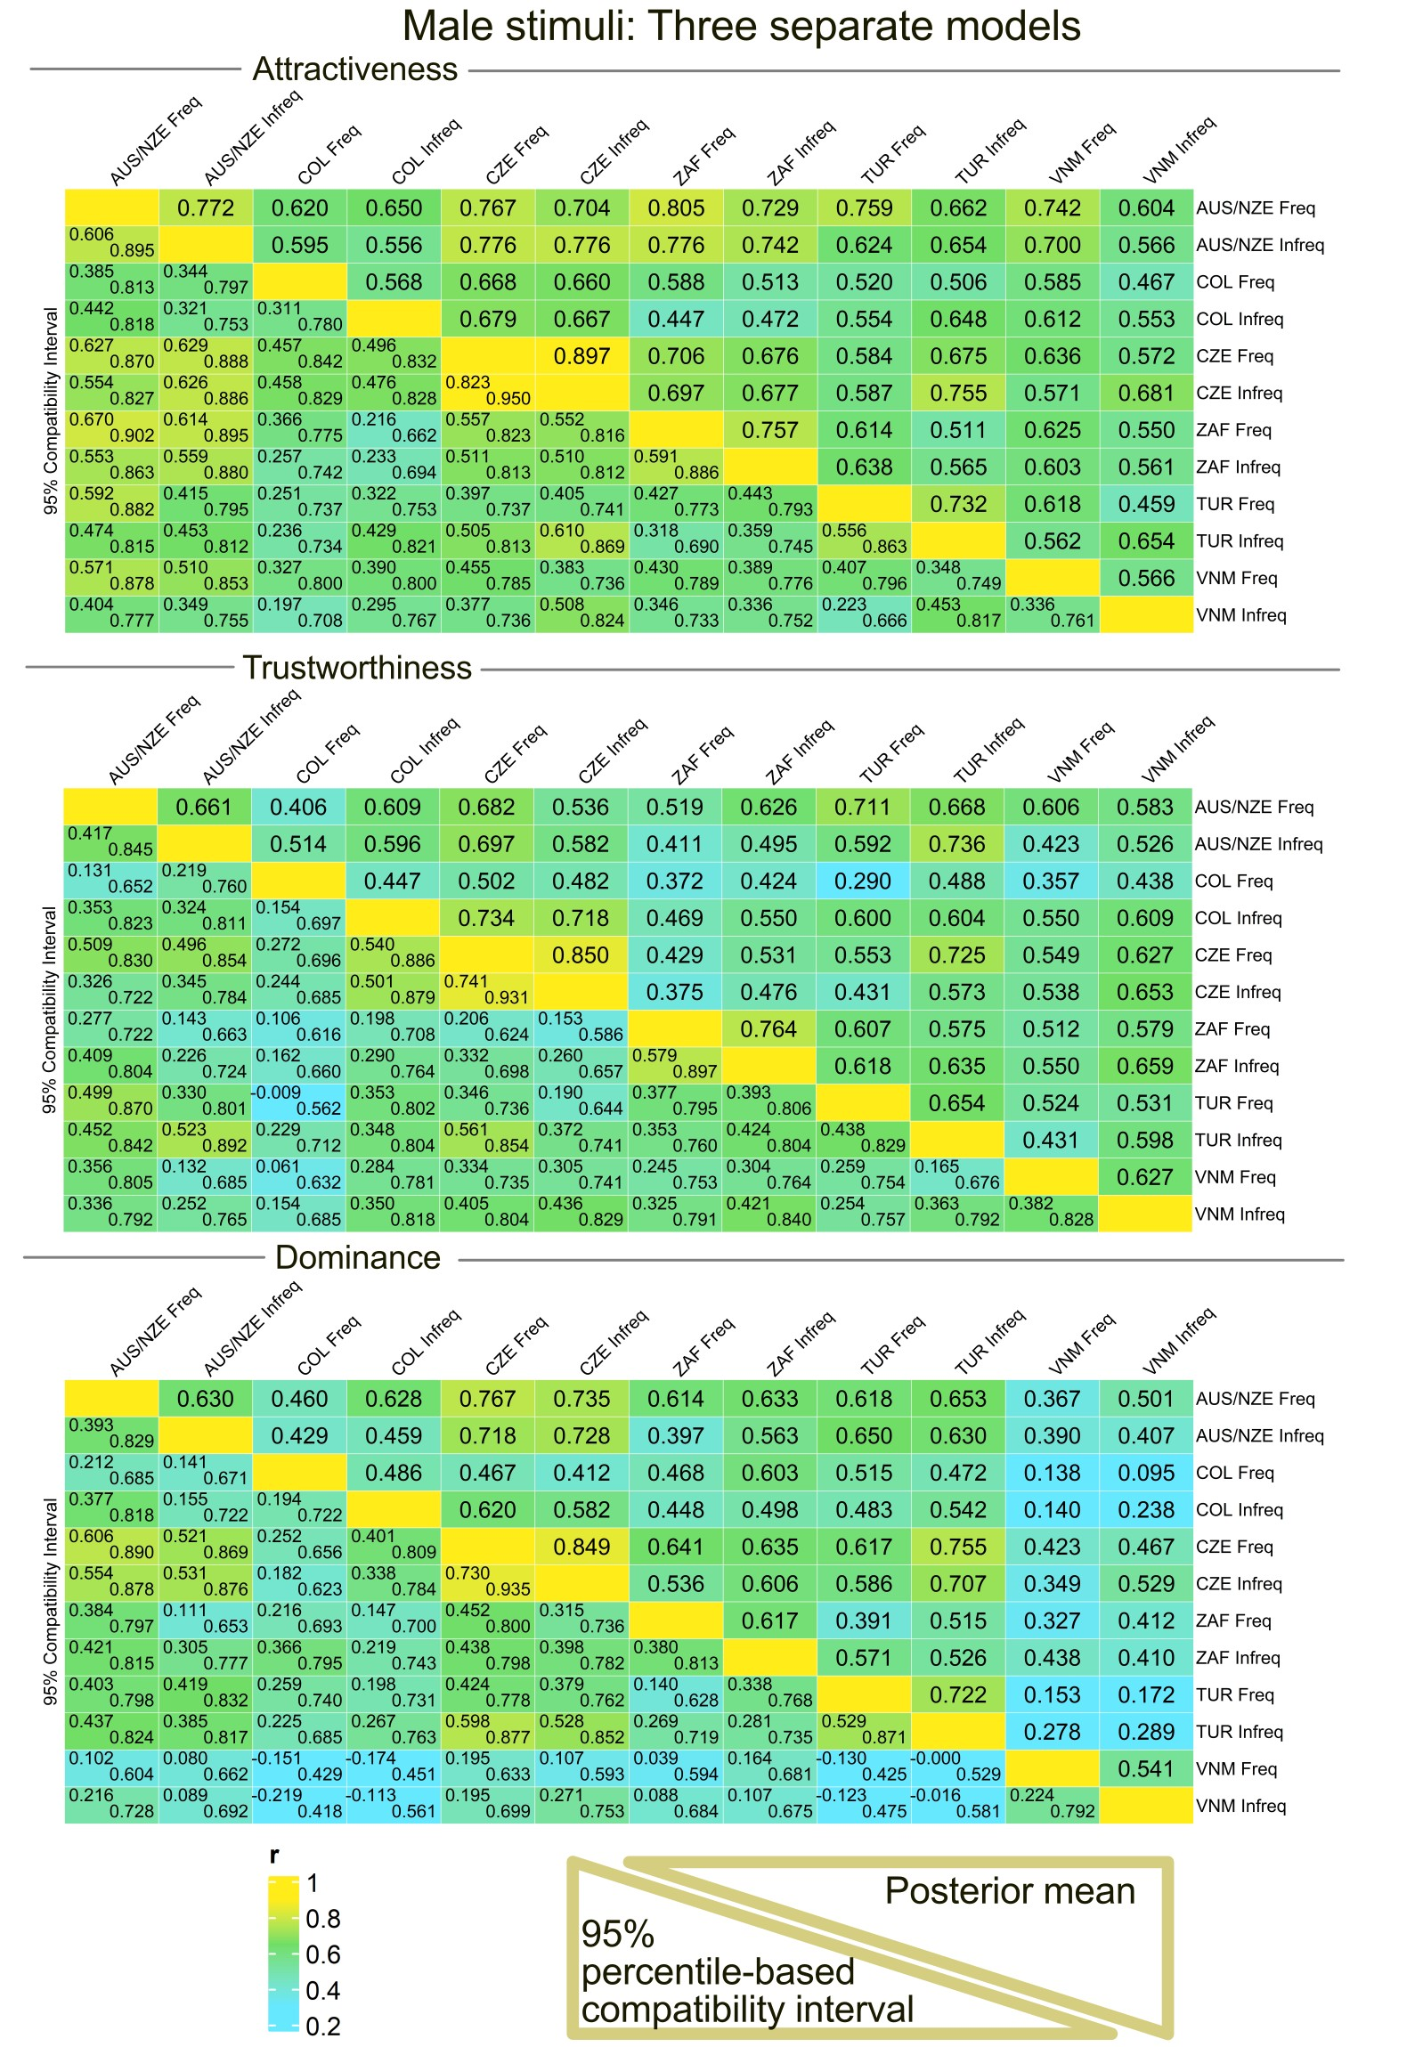

Figure S5 – Male stimuli. Detailed caption is identical like for Figure S1A.

### 1.2.2. An analogue of Fig. 3 in the article “Means & linear effects: Females”

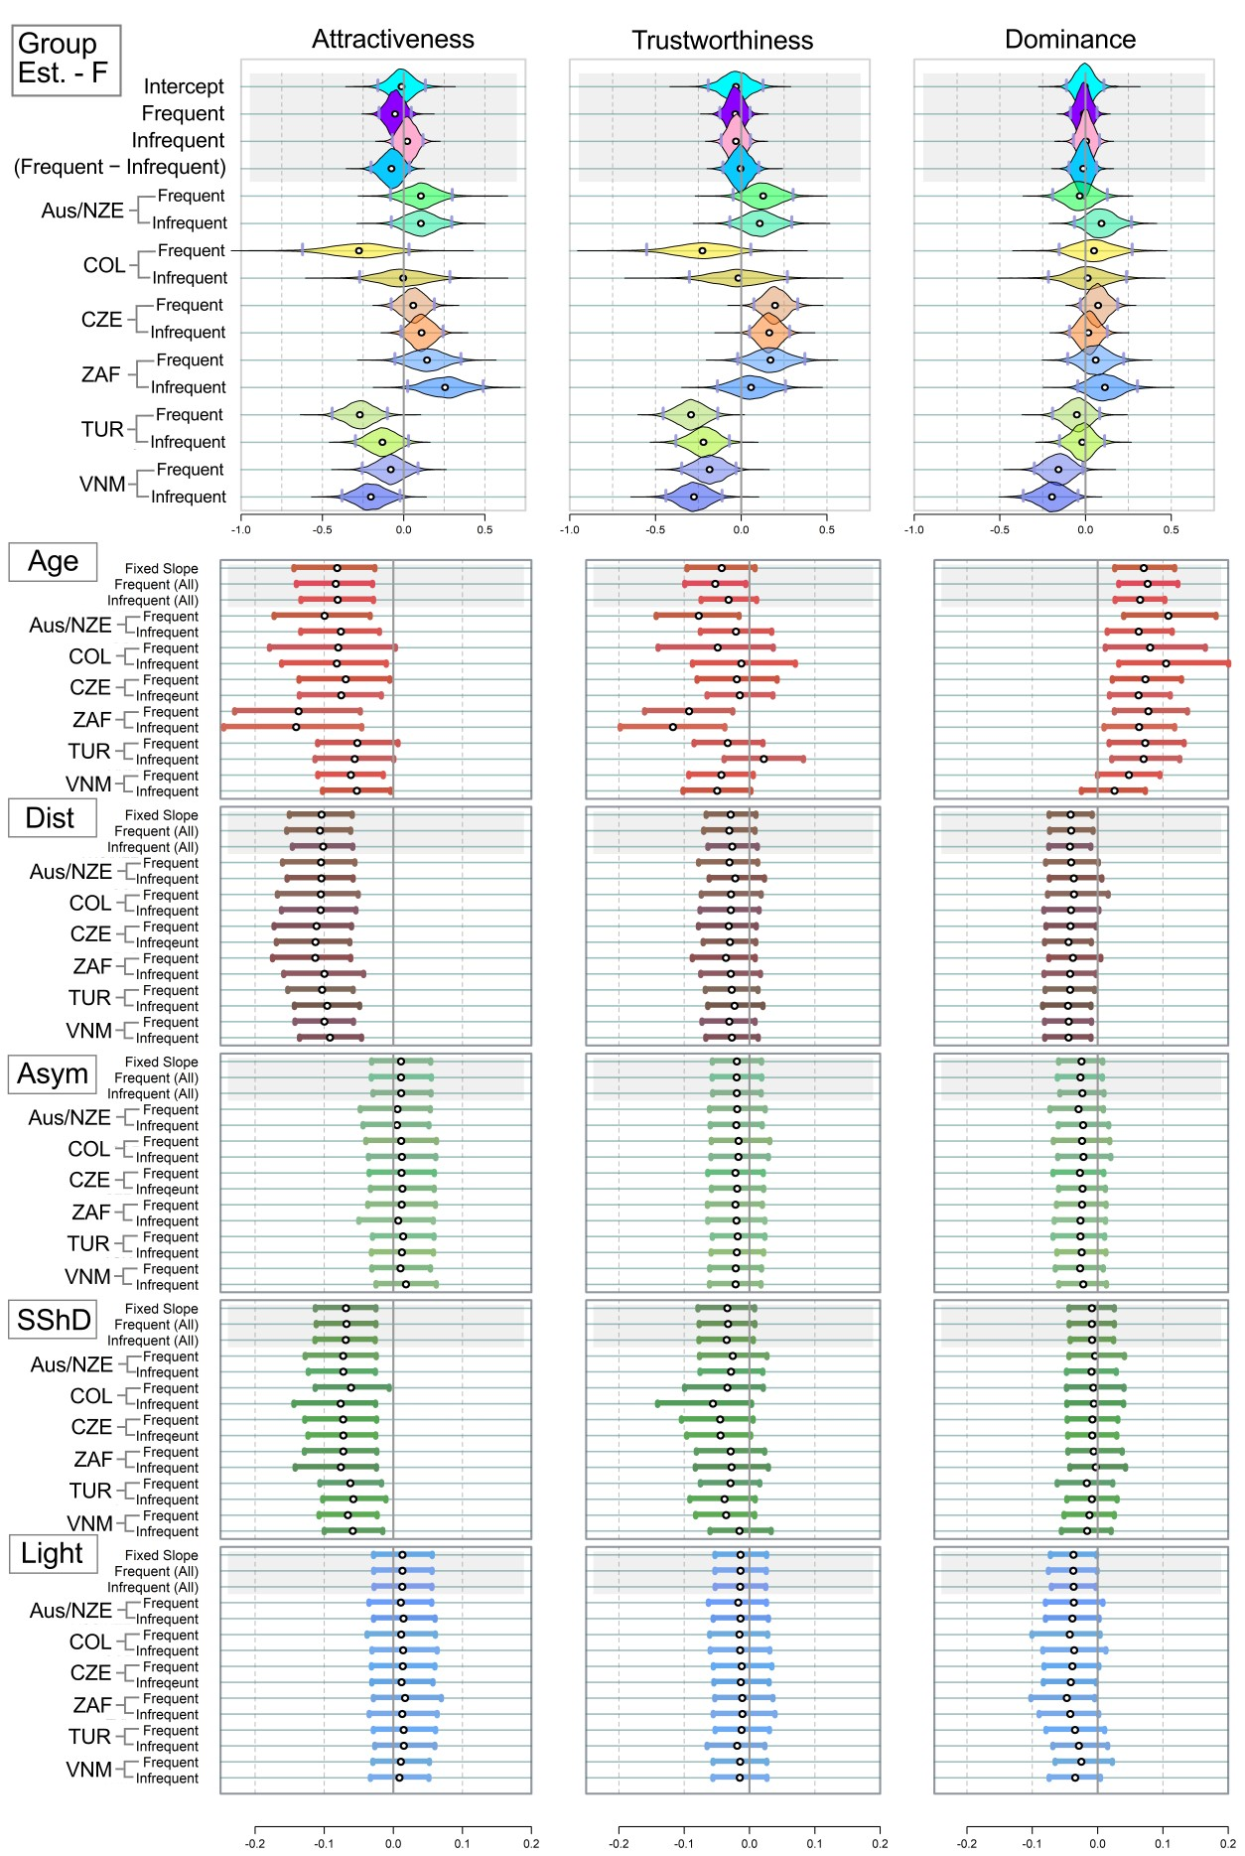

**Figure S6**. Mean estimated ratings of attractiveness, trustworthiness, and dominance in the twelve female stimuli. Analogue of Figure 3, run on separate models with sole dependent variable (attractiveness or trustworthiness or dominance). White point = Mean of the estimate; Grey Vertical Bars = Border of 95% percentile-based Compatibility Intervals. Dist = distinctiveness; Asym = facial asymmetry; SShD = Sexual Shape Dimorphism; Light = Skin lightness. Group Est. = Group Estimates - average ratings assigned to the faces in the group of frequent and infrequent users per population. Like in Figure 1 and 2, the country abbreviations correspond to three-letter country codes (ISO 3166-1 alpha-3).

### 1.2.3. An analogue of Figure 4 in the article “Means & linear effects: Males”

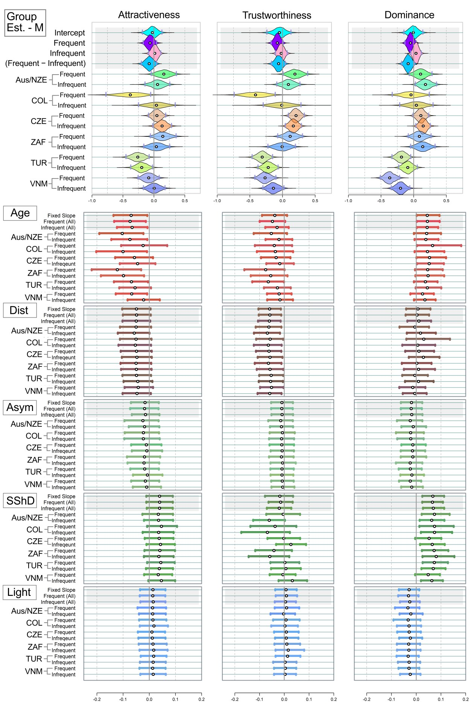

**Figure S7**. Mean estimated ratings of attractiveness, trustworthiness, and dominance, Males.

## Part 1.3. Model with the three response variables - attractiveness, trustworthiness, and dominance: model predictions

Model transcription:

ATD_model <- ulam(alist(

# Multivariate normal for Trustworthiness and Attractiveness

c(AtrRating, TrustwRating, DomRating) ~ multi_normal(c(muA, muT, muD), Rho_Scales, sigma_Scales),

# ATTRACTIVENESS

muA <- z_rNV_A[rater] * sigma_rater_A

+ f_per_group_A[face, FSMUi] # per face - per culture

+ (aA + f_per_group_pr_A[FSMUi,1])

+ (b_age_A + f_per_group_pr_A[FSMUi, 2]) * Age

+ (b_dist_A + f_per_group_pr_A[FSMUi, 3]) * dist

+ (b_FA_A + f_per_group_pr_A[FSMUi, 4]) * FA

+ (b_sshd_A + f_per_group_pr_A[FSMUi, 5]) * sshd

+ (b_L_A + f_per_group_pr_A[FSMUi,6]) * L,

aA ~ dnorm(0, 0.5), #

b_age_A ~ dnorm(0, 0.3),

b_dist_A ~ dnorm(0, 0.3),

b_FA_A ~ dnorm(0, 0.3),

b_sshd_A ~ dnorm(0, 0.3),

b_L_A ~ dnorm(0, 0.3),

# Non-centered parameterization for rater effects

z_rNV_A[rater] ~ dnorm(0, 1), # latent variable

sigma_rater_A ~ dexp(1), # Attractiveness

gq> vector[rater]:a_rNV_A <<- aA + z_rNV_A * sigma_rater_A, # Generate rater effects for Attractiveness

# Varying effects for Attractiveness morpho-predictors

transpars> matrix[FSMUi, 6]:f_per_group_pr_A <- compose_noncentered(sigma_pr_A, L_Rho_pr_A, z_pr_A),

cholesky_factor_corr[6]:L_Rho_pr_A ~ lkj_corr_cholesky(2),

matrix[6, FSMUi]:z_pr_A ~ normal(0, 1),

vector[6]:sigma_pr_A ~ dexp(1),

gq> matrix[6, 6]:Rho_pr_A <<- Chol_to_Corr(L_Rho_pr_A),

# Priors for the multivariate normal distribution for face intercepts across groups

transpars> matrix[face, 12]:f_per_group_A <- compose_noncentered(sigma_FSMUi_A, L_Rho_FSMUi_A, z_FSMUi_A),

cholesky_factor_corr[12]:L_Rho_FSMUi_A ~ lkj_corr_cholesky(2),

matrix[12, face]:z_FSMUi_A ~ normal(0, 1),

vector[12]:sigma_FSMUi_A ~ dexp(1),

gq> matrix[12, 12]:Rho_FSMUi_A <<- Chol_to_Corr(L_Rho_FSMUi_A),

# TRUSTWORTHINESS

muT <- z_rNV_T[rater] * sigma_rater_T

+ f_per_group_T[face, FSMUi] # per face - per culture

+ (aT + f_per_group_pr_T[FSMUi, 1])

+ (b_age_T + f_per_group_pr_T[FSMUi, 2]) * Age

+ (b_dist_T + f_per_group_pr_T[FSMUi, 3]) * dist

+ (b_FA_T + f_per_group_pr_T[FSMUi, 4]) * FA

+ (b_sshd_T + f_per_group_pr_T[FSMUi, 5]) * sshd

+ (b_L_T + f_per_group_pr_T[FSMUi, 6]) * L,

aT ~ dnorm(0, 0.5),

b_age_T ~ dnorm(0, 0.3),

b_dist_T ~ dnorm(0, 0.3),

b_FA_T ~ dnorm(0, 0.3),

b_sshd_T ~ dnorm(0, 0.3),

b_L_T ~ dnorm(0, 0.3),

z_rNV_T[rater] ~ dnorm(0, 1), # Trustworthiness latent variable

sigma_rater_T ~ dexp(1),

gq> vector[rater]:a_rNV_T <<- aT + z_rNV_T * sigma_rater_T, # Generate rater effects for Trustworthiness

# Varying effects for Trustworthiness morpho-predictors

transpars> matrix[FSMUi, 6]:f_per_group_pr_T <- compose_noncentered(sigma_pr_T, L_Rho_pr_T, z_pr_T),

cholesky_factor_corr[6]:L_Rho_pr_T ~ lkj_corr_cholesky(2),

matrix[6, FSMUi]:z_pr_T ~ normal(0, 1),

vector[6]:sigma_pr_T ~ dexp(1),

gq> matrix[6, 6]:Rho_pr_T <<- Chol_to_Corr(L_Rho_pr_T),

transpars> matrix[face, 12]:f_per_group_T <- compose_noncentered(sigma_FSMUi_T, L_Rho_FSMUi_T, z_FSMUi_T),

cholesky_factor_corr[12]:L_Rho_FSMUi_T ~ lkj_corr_cholesky(2),

matrix[12, face]:z_FSMUi_T ~ normal(0, 1),

vector[12]:sigma_FSMUi_T ~ dexp(1),

gq> matrix[12, 12]:Rho_FSMUi_T <<- Chol_to_Corr(L_Rho_FSMUi_T),

# DOMINANCE

muD <- z_rNV_D[rater] * sigma_rater_D

+ f_per_group_D[face, FSMUi] # per face - per culture

+ (aD + f_per_group_pr_D[FSMUi,1])

+ (b_age_D + f_per_group_pr_D[FSMUi, 2]) * Age

+ (b_dist_D + f_per_group_pr_D[FSMUi, 3]) * dist

+ (b_FA_D + f_per_group_pr_D[FSMUi, 4]) * FA

+ (b_sshd_D + f_per_group_pr_D[FSMUi, 5]) * sshd

+ (b_L_D + f_per_group_pr_D[FSMUi, 6]) * L,

aD ~ dnorm(0, 0.5),

b_age_D ~ dnorm(0, 0.3),

b_dist_D ~ dnorm(0, 0.3),

b_FA_D ~ dnorm(0, 0.3),

b_sshd_D ~ dnorm(0, 0.3),

b_L_D ~ dnorm(0, 0.3),

# Non-centered parameterization for rater effects

z_rNV_D[rater] ~ dnorm(0, 1), # latent variable

sigma_rater_D ~ dexp(1), # Dominance

gq> vector[rater]:a_rNV_D <<- aD + z_rNV_D * sigma_rater_D,

transpars> matrix[FSMUi, 6]:f_per_group_pr_D <- compose_noncentered(sigma_pr_D, L_Rho_pr_D, z_pr_D),

cholesky_factor_corr[6]:L_Rho_pr_D ~ lkj_corr_cholesky(2),

matrix[6, FSMUi]:z_pr_D ~ normal(0, 1),

vector[6]:sigma_pr_D ~ dexp(1),

gq> matrix[6, 6]:Rho_pr_D <<- Chol_to_Corr(L_Rho_pr_D),

# Priors for the multivariate normal distribution for face intercepts across groups

transpars> matrix[face, 12]:f_per_group_D <- compose_noncentered(sigma_FSMUi_D, L_Rho_FSMUi_D, z_FSMUi_D),

cholesky_factor_corr[12]:L_Rho_FSMUi_D ~ lkj_corr_cholesky(2),

matrix[12, face]:z_FSMUi_D ~ normal(0, 1),

vector[12]:sigma_FSMUi_D ~ dexp(1),

gq> matrix[12, 12]:Rho_FSMUi_D <<- Chol_to_Corr(L_Rho_FSMUi_D),

# Common terms

Rho_Scales ~ lkj_corr(2),

sigma_Scales ~ dexp(1)

), data=data, iter=700, sample=T, cores=14, chains=14)

Below we provide additional tables and extended versions of the tables provided in the article.

Selected comparisons:

|  |  |  |  |
| --- | --- | --- | --- |
| **Table S4**. Correlation comparisons: extended | | | |
| *Female stimuli* | Attractiveness | Trustworthiness | Dominance |
| Mean: Czech Users | 0.95 [0.90; 0.98] | 0.90 [0.82; 0.96] | 0.88 [0.78; 0.95] |
| Mean: All other Users | 0.69 [0.63; 0.74] | 0.60 [0.54; 0.66] | 0.47 [0.40; 0.54] |
| Difference | 0.26 [0.20; 0.32] | 0.30 [0.21; 0.39] | 0.41 [0.30; 0.51] |
| *Male stimuli* | Attractiveness | Trustworthiness | Dominance |
| Mean: Czech Users | 0.91 [0.84; 0.96] | 0.87 [0.77; 0.94] | 0.84 [0.73; 0.93] |
| Mean: All other Users | 0.66 [0.60; 0.72] | 0.57 [0.51; 0.64] | 0.51 [0.44; 0.58] |
| Difference | 0.25 [0.17; 0.32] | 0.29 [0.18; 0.39] | 0.33 [0.21; 0.43] |
| *Female stimuli* | Attractiveness | Trustworthiness | Dominance |
| Mean: CZ+AUS/NZE Users | 0.88 [0.82; 0.92] | 0.77 [0.68; 0.85] | 0.71 [0.61; 0.81] |
| Mean: All other Users | 0.68 [0.62; 0.73] | 0.59 [0.52; 0.65] | 0.45 [0.38; 0.52] |
| Difference | 0.20 [0.14; 0.27] | 0.18 [0.08; 0.27] | 0.26 [0.15; 0.37] |
| *Male stimuli* | Attractiveness | Trustworthiness | Dominance |
| Mean: CZ+AUS/NZE Users | 0.80 [0.73; 0.87] | 0.69 [0.58; 0.79] | 0.75 [0.65; 0.83] |
| Mean: All other Users | 0.65 [0.59; 0.71] | 0.57 [0.50; 0.64] | 0.49 [0.42; 0.57] |
| Difference | 0.16 [0.08; 0.23] | 0.12 [0.01; 0.22] | 0.25 [0.15; 0.35] |
| *Female stimuli* | Attractiveness | Trustworthiness | Dominance |
| Mean: Prolific (AUS/NZE+RSA) | 0.70 [0.62; 0.78] | 0.65 [0.53; 0.75] | 0.60 [0.47; 0.72] |
| Mean: All other Users | 0.69 [0.64; 0.74] | 0.60 [0.54; 0.66] | 0.47 [0.39; 0.53] |
| Difference | 0.01 [0.07; 0.08] | 0.04 [-0.06; 0.15] | 0.14 [0.01; 0.26] |
| *Male stimuli* | Attractiveness | Trustworthiness | Dominance |
| Mean: Prolific (AUS/NZE+RSA) | 0.72 [0.63; 0.81] | 0.64 [0.51; 0.74] | 0.61 [0.48; 0.72] |
| Mean: All other Users | 0.66 [0.59; 0.72] | 0.57 [0.50; 0.64] | 0.51 [0.43; 0.58] |
| Difference | 0.06 [-0.02; 0.15] | 0.06 [-0.05; 0.17] | 0.10 [-0.01; 0.22] |

## Part 2. Model with the three response variables (attractiveness, trustworthiness, dominance), raters who scored in a 25% band around median in at least 2 of the three scales excluded

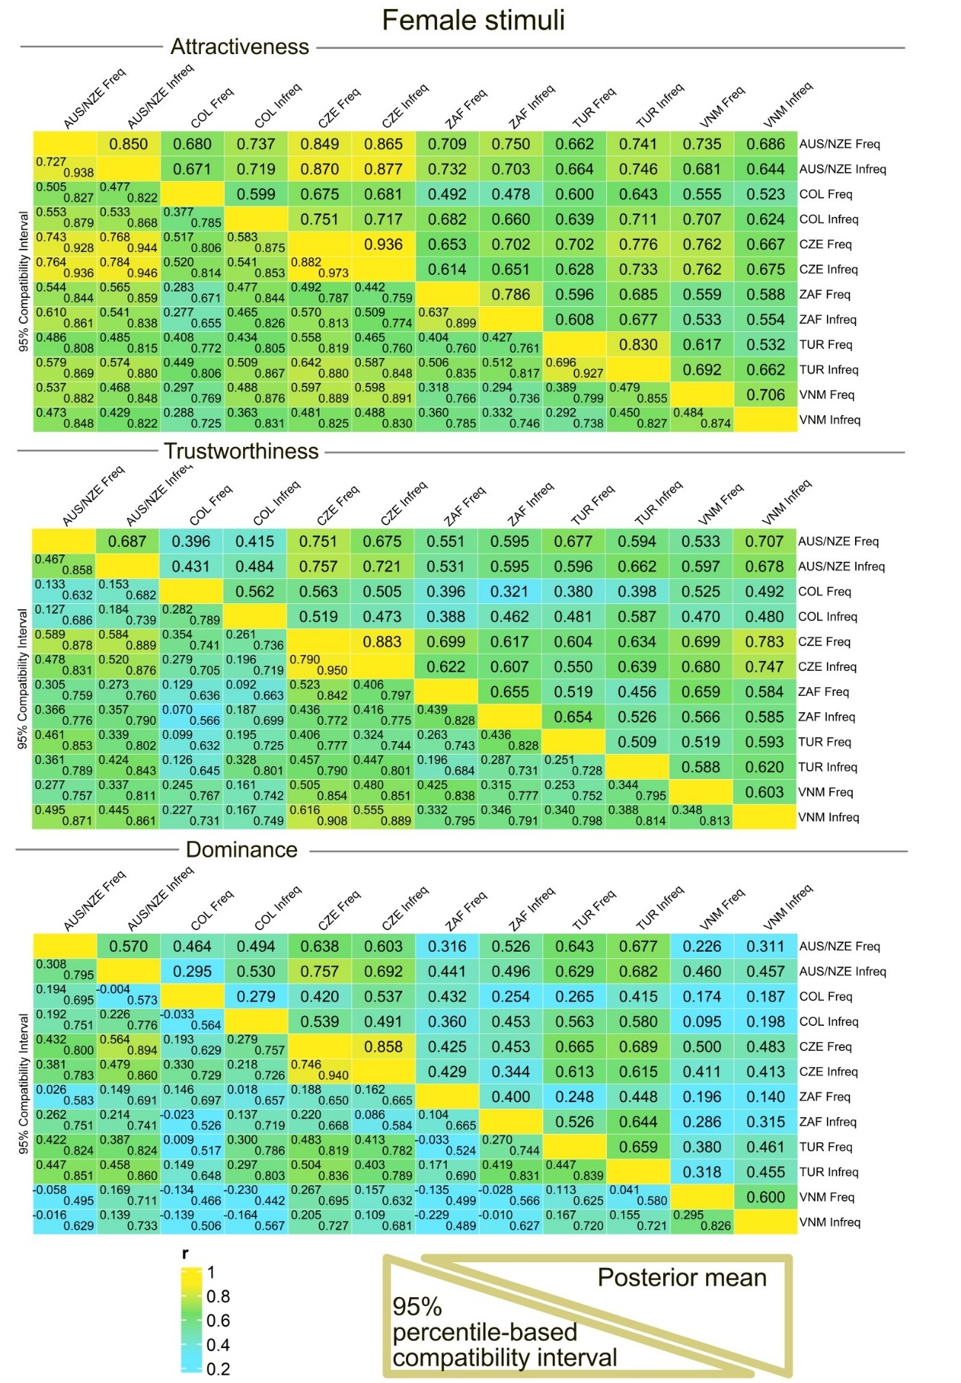

**Figure S8**. Posterior distributions of correlation coefficients: association between ratings in different samples (Freq = users above median in social media use frequency; Infreq = users below the median). Female stimuli. Predictions based on a model with three dependent variables (Attractiveness, Trustworthiness, and Dominance), participants within 25% band around median in social media use intensity for at least two out of three scales excluded. NewZ in the upper panel = New Zealand. Abbreviations in the lower panel (CZE [Czechia], AUS/NZE [Australia/New Zealand], TUR [Turkey], COL [Colombia], VNM [Vietnam], ZAF [South Africa]) correspond to three-letter country codes (ISO 3166-1 alpha-3).

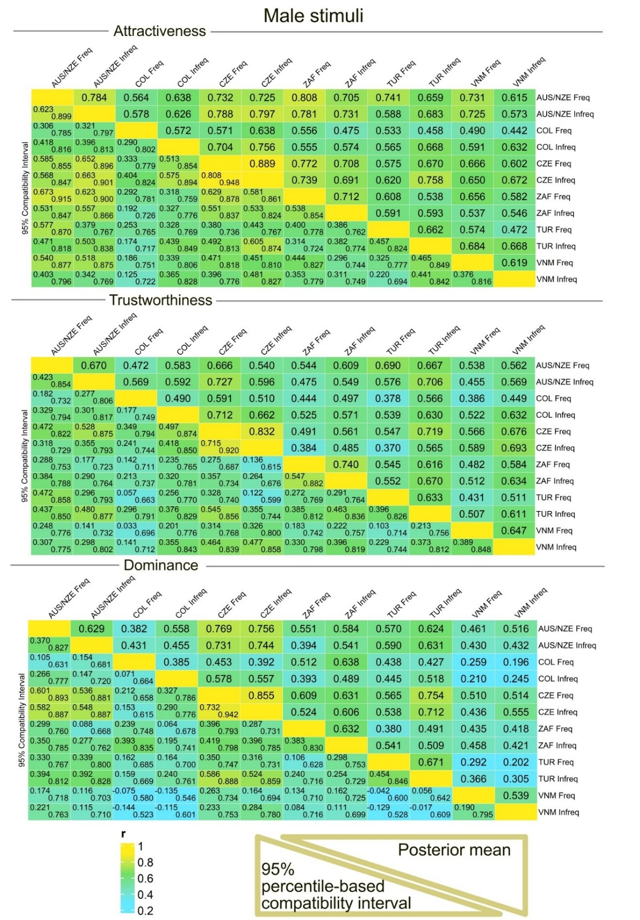

**Figure S9**. Posterior distributions of correlation coefficients: association between ratings in different samples (Freq = users above median in social media use frequency; Infreq = users below the median). Male stimuli. Predictions based on a model with three dependent variables (Attractiveness, Trustworthiness, and Dominance), participants within 25% band around median in social media use intensity for at least two out of three scales excluded. 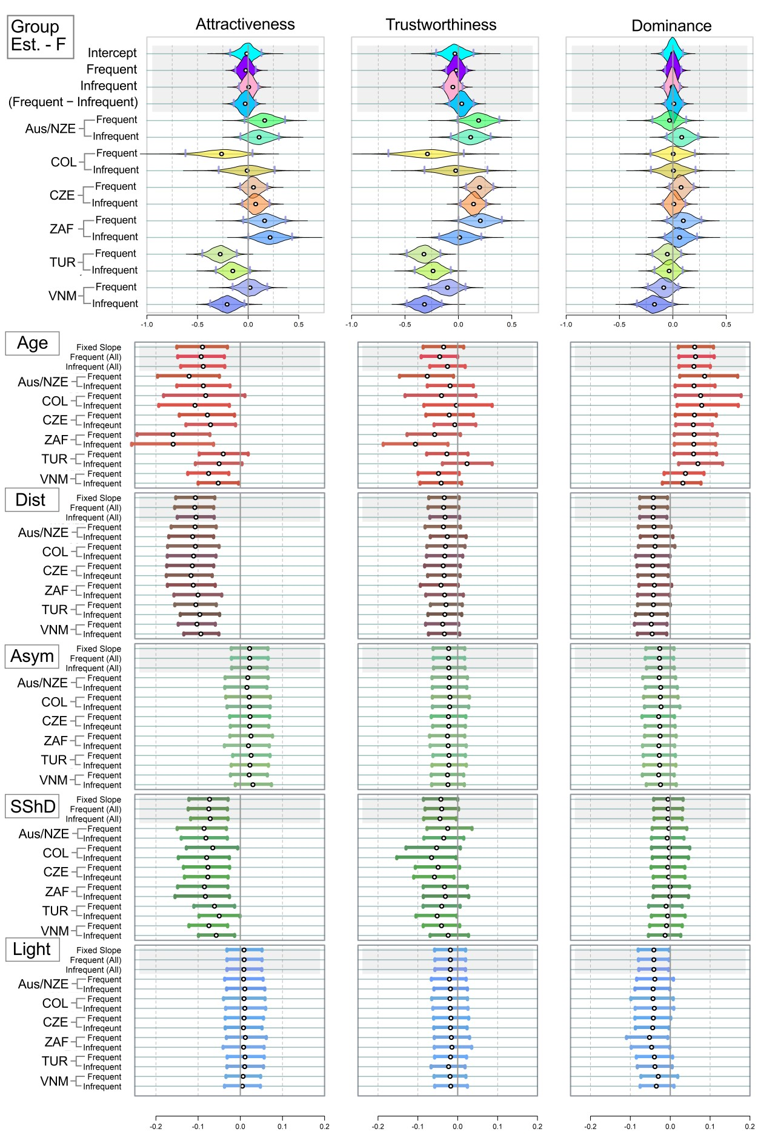

**Figure S10**. Mean estimated ratings of attractiveness, trustworthiness, and dominance in female stimuli. Analogue of Figure 3, run on models with the three dependent variables (attractiveness or trustworthiness or dominance), participants within 25% band around median in social media use intensity for at least two out of three scales excluded. White point = Mean of the estimate; Grey Vertical Bars = Border of 95% percentile-based Compatibility Intervals. Dist = distinctiveness; Asym = facial asymmetry; SShD = Sexual Shape Dimorphism; Light = Skin lightness. Group Est. = Group Estimates - average ratings assigned to the faces in the group of frequent and infrequent users per population. Like in Figures above, the country abbreviations correspond to three-letter country codes.

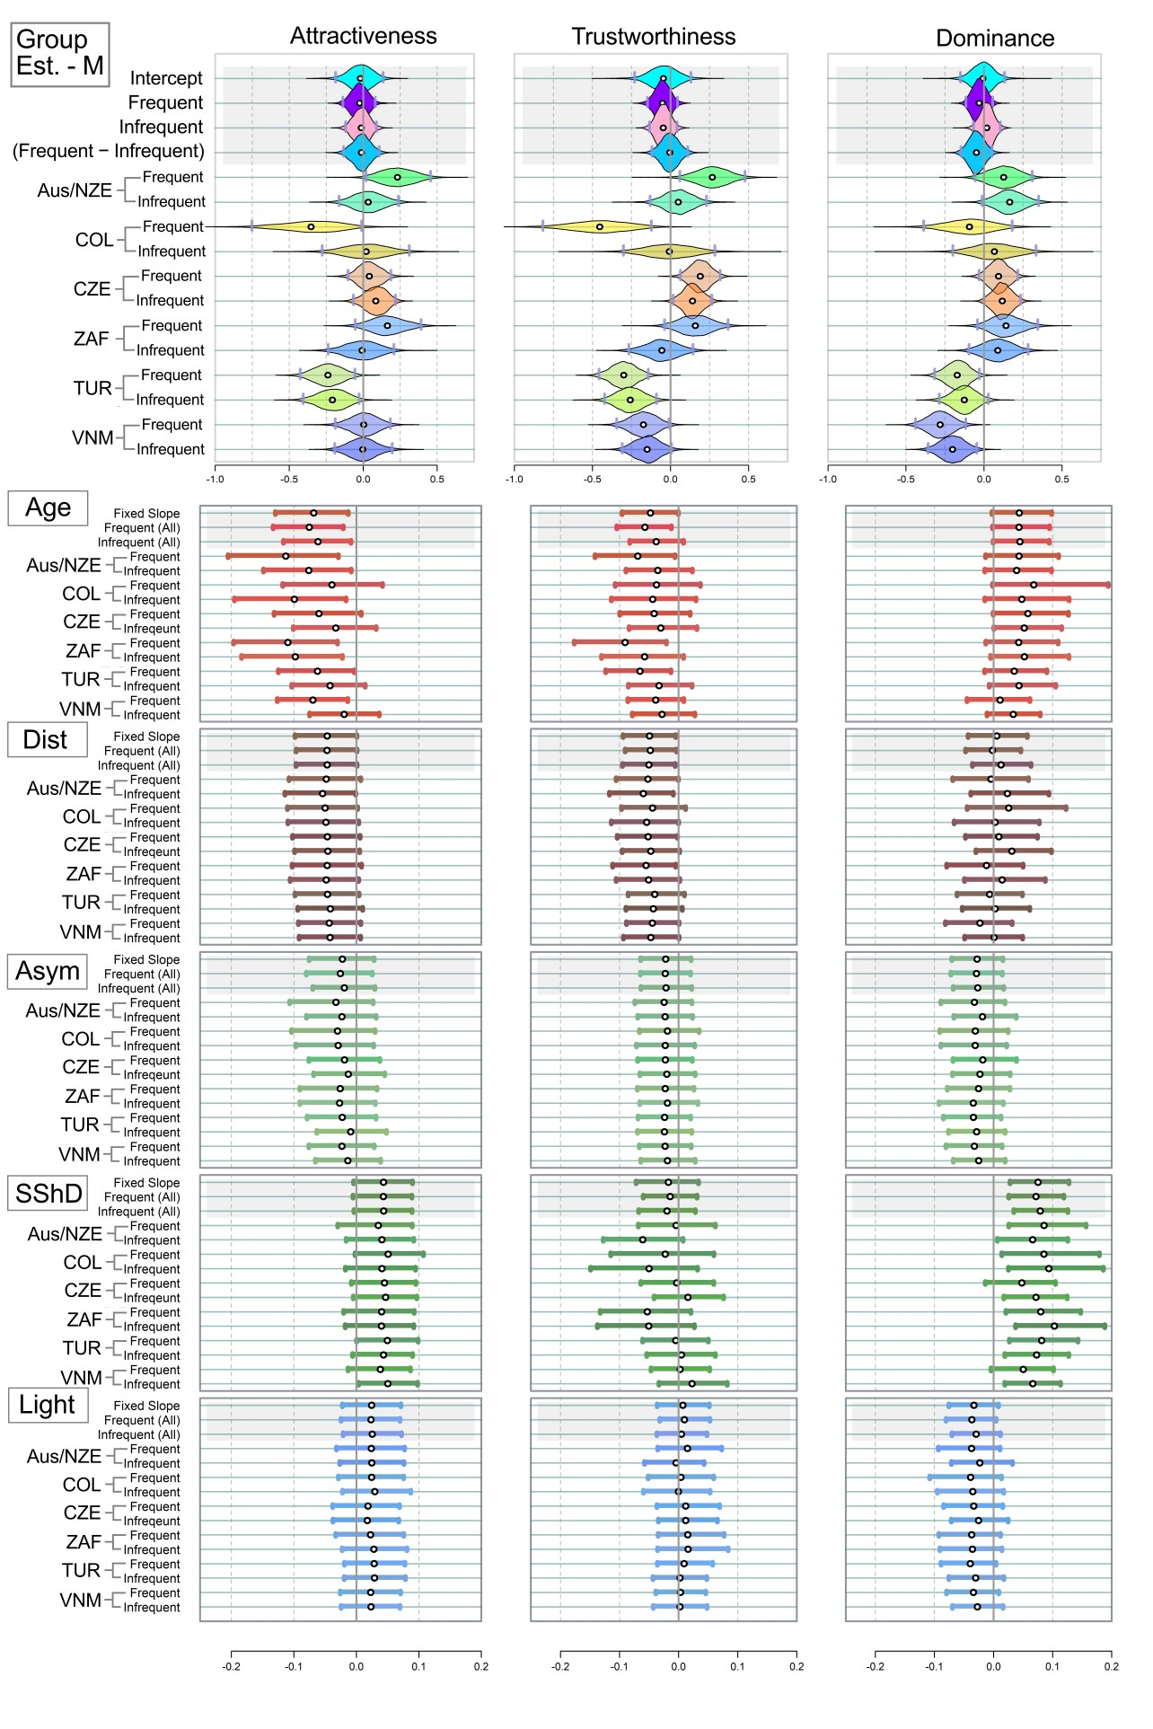

**Figure S11**. Mean estimated ratings of attractiveness, trustworthiness, and dominance in male stimuli. Analogue of Figure 3, run on models with the three dependent variables (attractiveness or trustworthiness or dominance), participants within 25% band around median in social media use intensity for at least two out of three scales excluded.

|  |  |  |  |
| --- | --- | --- | --- |
| **Table S4.** Correlation comparisons. Mean stands for “Mean correlation”. Participants within 25% band around median in social media use intensity for at least two out of three scales excluded. | | | |
| Female stimuli | Attractiveness | Trustworthiness | Dominance |
| Mean within cultures | **0.78 [0.72; 0.84]** | **0.65 [0.56; 0.74]** | **0.56 [0.45; 0.66]** |
| Mean across cultures | **0.68 [0.62; 0.73]** | **0.56 [0.48; 0.63]** | **0.45 [0.37; 0.52]** |
| *Difference* | ***0.11 [0.05; 0.17]*** | ***0.09 [0.01; 0.17]*** | ***0.11 [0.01; 0.21]*** |
| Mean: Frequent users | **0.66 [0.58; 0.73]** | **0.56 [0.47; 0.66]** | **0.56 [0.47; 0.66]** |
| Mean: Infrequent users | **0.69 [0.61; 0.76]** | **0.59 [0.49; 0.68]** | **0.49 [0.38; 0.60]** |
| *Difference* | **−*0.03 [*−*0.13; 0.06]*** | **−*0.03 [*−*0.15; 0.10]*** | ***0.07 [*−*0.07; 0.22]*** |
| Male stimuli | Attractiveness | Trustworthiness | Dominance |
| Mean within cultures | **0.71 [0.62; 0.78]** | **0.67 [0.57; 0.75]** | **0.62 [0.51; 0.71]** |
| Mean across cultures | **0.62 [0.55; 0.69]** | **0.56 [0.48; 0.63]** | **0.49 [0.41; 0.57]** |
| *Difference* | ***0.09 [0.02; 0.16]*** | ***0.11 [0.03; 0.20]*** | ***0.13 [0.02; 0.22]*** |
| Mean: Frequent users | **0.64 [0.55; 0.72]** | **0.52 [0.42; 0.62]** | **0.48 [0.38; 0.58]** |
| Mean: Infrequent users | **0.66 [0.58; 0.75]** | **0.61 [0.51; 0.70]** | **0.51 [0.41; 0.62]** |
| *Difference* | **−*0.03 [*−*0.14; 0.08]*** | **−*0.09 [*−*0.22; 0.04]*** | **−*0.04 [*−*0.17; 0.10]*** |

|  |  |  |  |
| --- | --- | --- | --- |
| **Table S5.** "Difference of differences" - Are average differences in mean estimates within a population always smaller than average differences between samples from different populations? (participants within 25% band around median in social media use intensity for at least two out of three scales excluded.) | | | |
| Female stimuli | Attractiveness | Trustworthiness | Dominance |
| Mean difference within samples | **0.16 [0.07; 0.26]** | **0.17 [0.08; 0.28]** | **0.09 [0.03; 0.18]** |
| Mean difference between samples | **0.24 [0.14; 0.33]** | **0.28 [0.21; 0.36]** | **0.12 [0.03; 0.20]** |
| Difference of the two differences | **0.08 [−0.00; 0.17]** | **0.11 [0.03; 0.21]** | **0.03 [−0.02; 0.09]** |
| Male stimuli | Attractiveness | Trustworthiness | Dominance |
| Mean difference within samples | **0.18 [0.08; 0.30]** | **0.19 [0.10; 0.31]** | **0.11 [0.05; 0.19]** |
| Mean difference between samples | **0.23 [0.12; 0.33]** | **0.29 [0.21; 0.38]** | **0.22 [0.15; 0.29]** |
| Difference of the two differences | **0.05 [−0.03; 0.14]** | **0.10 [0.02; 0.19]** | **0.11 [0.03; 0.19]** |

## Part 3. Travel abroad, Socioeconomic status during childhood

Line shows where the sample was split in half („above“ / „below“), upper line corresponds to „version_1“ (ver_1), lower line corresponds to „version_“2 (ver_2)

Line shows where the sample was split in half („above“ / „below“)

|  |  |  |  |  |  |  |
| --- | --- | --- | --- | --- | --- | --- |
| **Table** S9: Numbers of participants according to the frequency of their travel abroad and socioeconomic status: | | | | | | |
| **Abroad** | CZ | VN | RSA | AUS/ NZ | COL | TUR |
| Often | 29 | 6 | 2 | 1 | 0 | 5 |
| Rather Often | 50 | 3 | 2 | 5 | 0 | 7 |
| Occasionaly | 37 | 18 | 9 | 16 | 2 | 19 |
| Rarely | 19 | 9 | 6 | 10 | 0 | 9 |
| Very rarely | 17 | 15 | 10 | 21 | 5 | 8 |
| Never | 0 | 18 | 18 | 0 | 0 | 31 |
| Nas | 0 | 3 | 0 | 0 | 1 | 0 |
| **Econ** | CZ | VN | RSA | AUS/ NZ | COL | TUR |
| Rich | 13 | 12 | 2 | 7 | 1 | 10 |
| Upper CL | 31 | 23 | 13 | 23 | 1 | 37 |
| **Middle** | **62** | **7** | **23** | **11** | **6** | **15** |
| Lower CL | 42 | 12 | 7 | 8 | 1 | 1 |
| Poor | 4 | 5 | 2 | 3 | 4 | 10 |
| DoNotWanna | 0 | 0 | 0 | 1 | 0 | 5 |
| NAs | 0 | 0 | 0 | 0 | 0 | 1 |
|  |  |  |  |  |  |  |

Abroad = Frequency of travel abroad.   
Econ = Socioeconomic status during childhood.   
Both the variables are self-reported.   
Please note that in case of socioeconomic status, the result of the comparison below depends largely on the allocation of “Middle”. Especially, when sorted together wight “Rich” and “Upper CL”, number of participants in the rest of the groups causes the “below” group much smaller that the group “above”, when split into two, based on the socioeconomic status.

### Part 3.1. Travel abroad

Model layout is still the same, but “above/below” correspond to travel abroad frequency.   
**Travel abroad**: participants were splitted in two groups. Participants who reported they travel abroad "Often", "Rather Often" and "Occasionaly” are in one group (“above”), participants, who reported they travel abroad "Rarely", "Very rarely" or "Never" are in the other (“below”; NAs excluded).

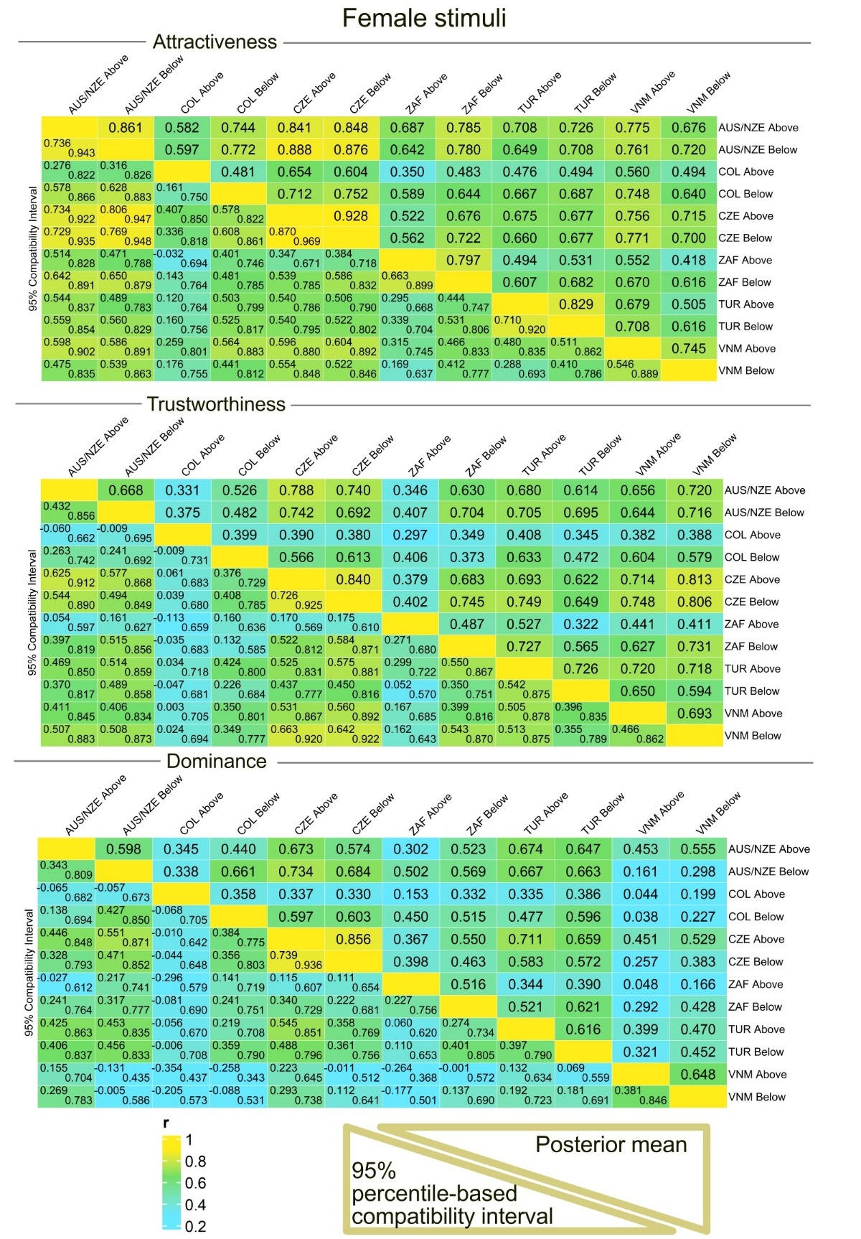

**Figure S12**. Participants from every country (the abbreviations are same as above), divided according to self-reported frequency of traveling abroad. Female stimuli. Please, mind that the numbers in some samples are low and unequal.

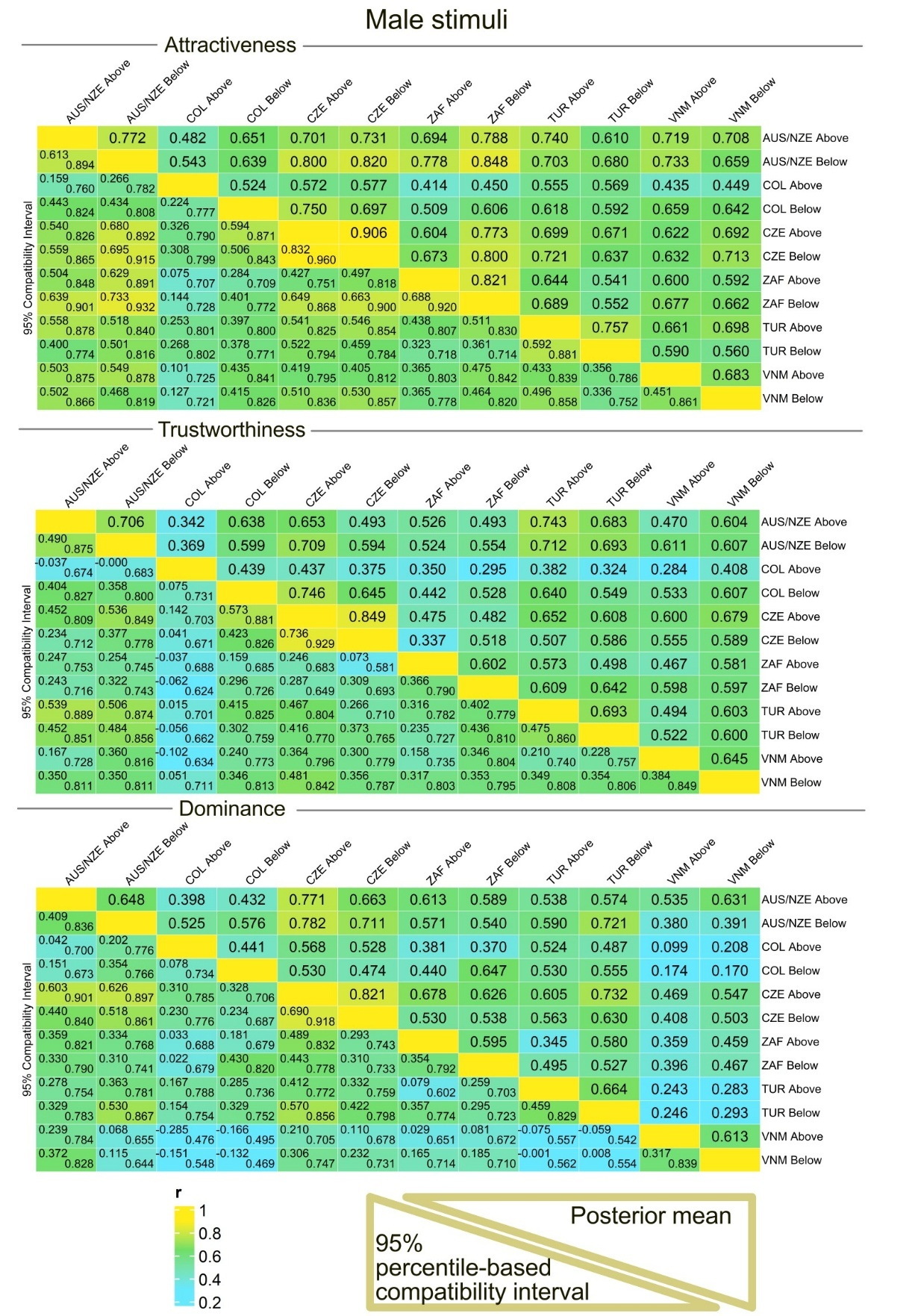

**Figure S13**. Participants from every country (the abbreviations are same as above), divided according to self-reported frequency of traveling abroad. Male stimuli. Please, mind that the numbers in some samples are low and unequal.

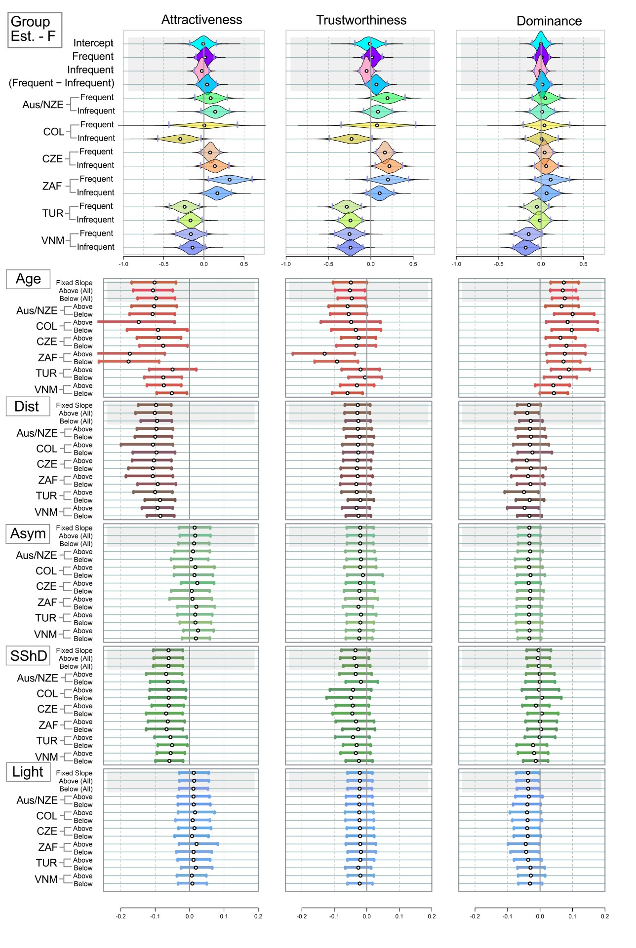

**Figure S14**. Mean estimated ratings of attractiveness, trustworthiness, and dominance in female stimuli. Analogue of Figure 3, run on models with the three dependent variables (attractiveness or trustworthiness or dominance), participants divided based on frequency of traveling abroad (above = Often, Rather Often, and Occasionally). White point = Mean of the estimate; Grey Vertical Bars = Border of 95% percentile-based Compatibility Intervals. Dist = distinctiveness; Asym = facial asymmetry; SShD = Sexual Shape Dimorphism; Light = Skin lightness. Group Est. = Group Estimates - average ratings assigned to the faces in the group of frequent and infrequent users per population. Like in Figures above, the country abbreviations correspond to three-letter country codes.

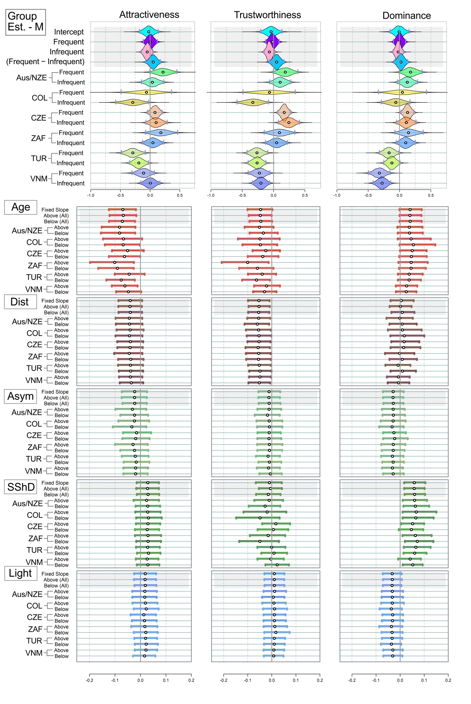

**Figure S15**. Mean estimated ratings of attractiveness, trustworthiness, and dominance in male stimuli. Analogue of Figure 3, run on models with the three dependent variables (attractiveness or trustworthiness or dominance), participants divided based on frequency of traveling abroad (above = Often, Rather Often, and Occasionally).

|  |  |  |  |
| --- | --- | --- | --- |
| **Table S6.** Correlation comparisons. Do those, who travel abroad more frequently (“above”), agree better with each other? Mean stands for “Mean correlation”. | | | |
| Female stimuli | Attractiveness | Trustworthiness | Dominance |
| Mean within cultures | **0.77 [0.70; 0.84]** | **0.64 [0.53; 0.72]** | **0.60 [0.49; 0.70]** |
| Mean across cultures | **0.65 [0.58; 0.72]** | **0.57 [0.40; 0.65]** | **0.44 [0.35; 0.52]** |
| *Difference* | ***0.12 [0.06; 0.17]*** | ***0.06 [*−*0.03; 0.15]*** | ***0.16 [0.06; 0.26]*** |
| Mean: Above travel users | **0.62 [0.52; 0.71]** | **0.52 [0.40; 0.62]** | **0.52 [0.40; 0.62]** |
| Mean: Below travel users | **0.71 [0.63; 0.77]** | **0.63 [0.54; 0.71]** | **0.52 [0.42; 0.62]** |
| *Difference* | **−*0.09 [*−*0.19; 0.01]*** | **−*0.11 [*−*0.24; 0.01]*** | ***0.00 [*−*0.15; 0.15]*** |
| Male stimuli | Attractiveness | Trustworthiness | Dominance |
| Mean within cultures | **0.74 [0.66; 0.81]** | **0.66 [0.56; 0.74]** | **0.63 [0.53; 0.73]** |
| Mean across cultures | **0.65 [0.58; 0.71]** | **0.54 [0.46; 0.61]** | **0.50 [0.42; 0.57]** |
| *Difference* | ***0.09 [0.02; 0.16]*** | ***0.12 [0.03; 0.20]*** | ***0.13 [0.04; 0.23]*** |
| Mean: Above travel users | **0.61 [0.51; 0.70]** | **0.50 [0.38; 0.61]** | **0.48 [0.36; 0.58]** |
| Mean: Below travel users | **0.67 [0.59; 0.75]** | **0.59 [0.50; 0.68]** | **0.52 [0.42; 0.61]** |
| *Difference* | **−*0.06 [*−*0.18; 0.05]*** | **−*0.10 [*−*0.23; 0.03]*** | **−*0.04 [*−*0.18; 0.09]*** |

### Part 3.2. Socioeconomic status during childhood – ver. 1

Model layout is still the same, but “above/below” correspond to socioeconomic status.   
**Socioeconomic status (SES)**: participants were split in two groups. Participants who reported their Socioeconomic status during childhood as "Rich", "Upper CL" were coded as “above”, the rest of the participants is “below” (NAs and “those who do not want to respond” excluded).

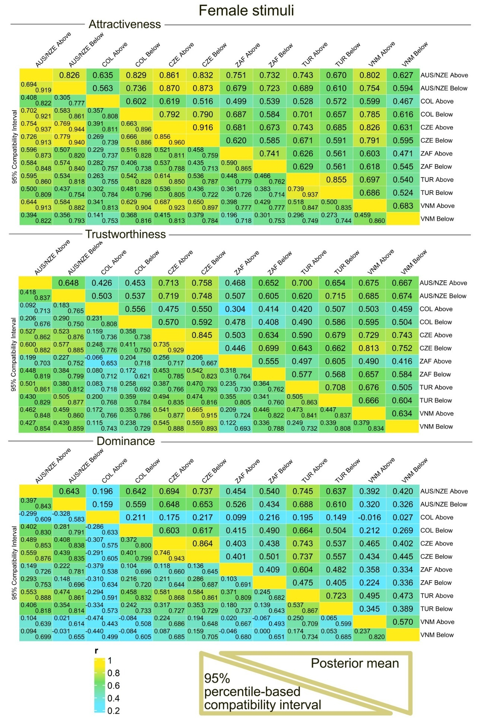

**Figure S16**. Participants from every country (the abbreviations are same as above), divided according to self-reported SES. Female stimuli. Please, mind that the numbers in some samples are low and unequal. *Version 1.*

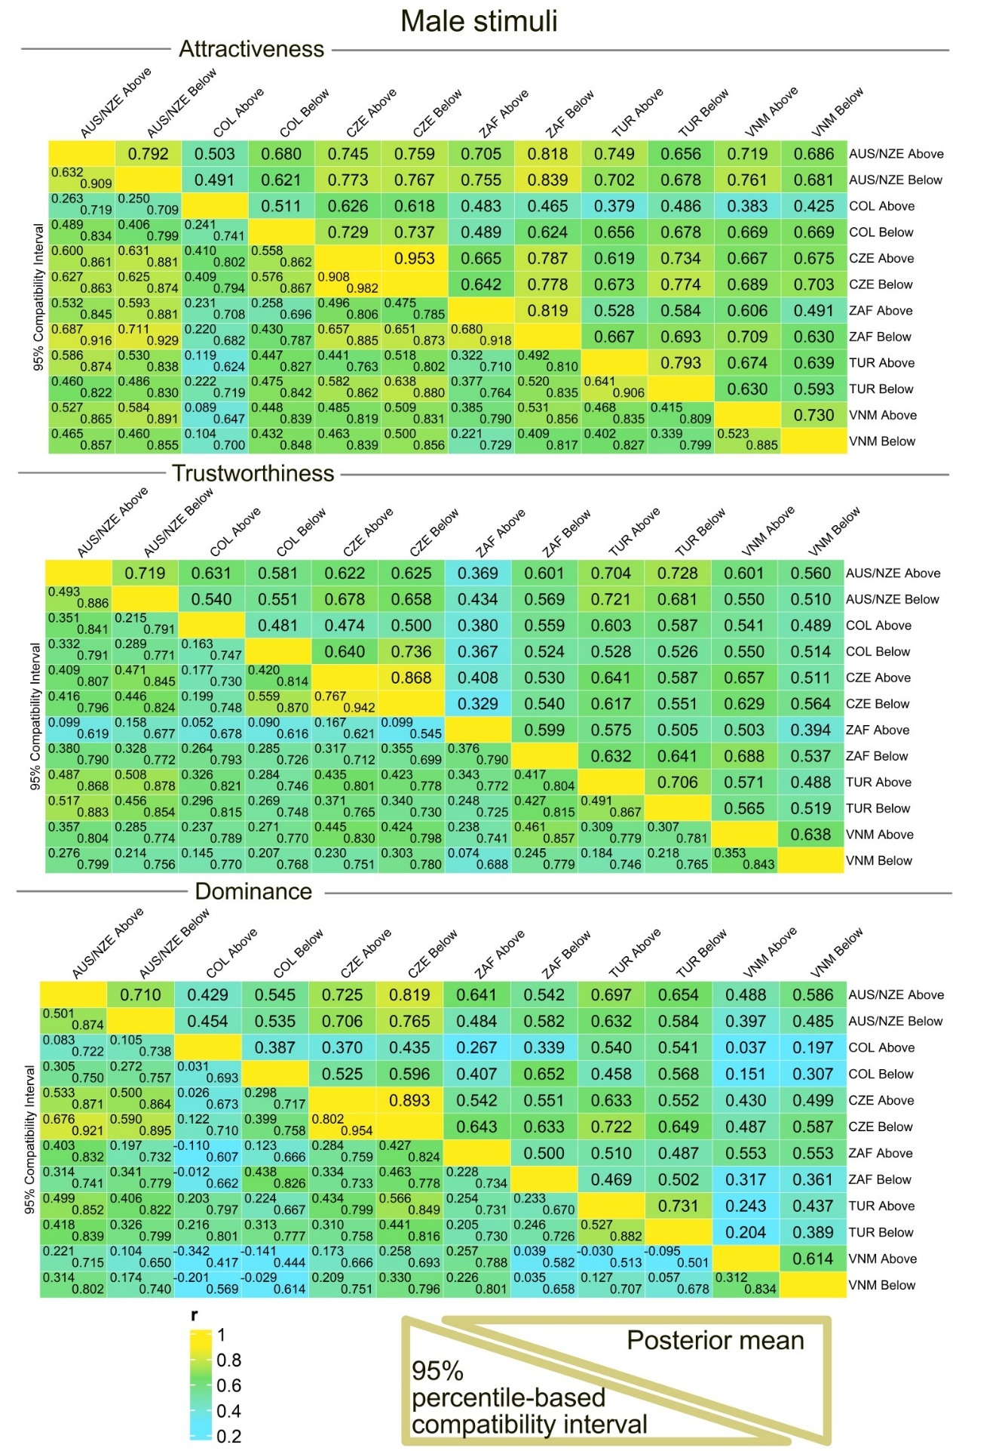

**Figure S17**. Participants from every country (the abbreviations are same as above), divided according to self-reported SES. Male stimuli. Please, mind that the numbers in some samples are low and unequal. *Version 1.*

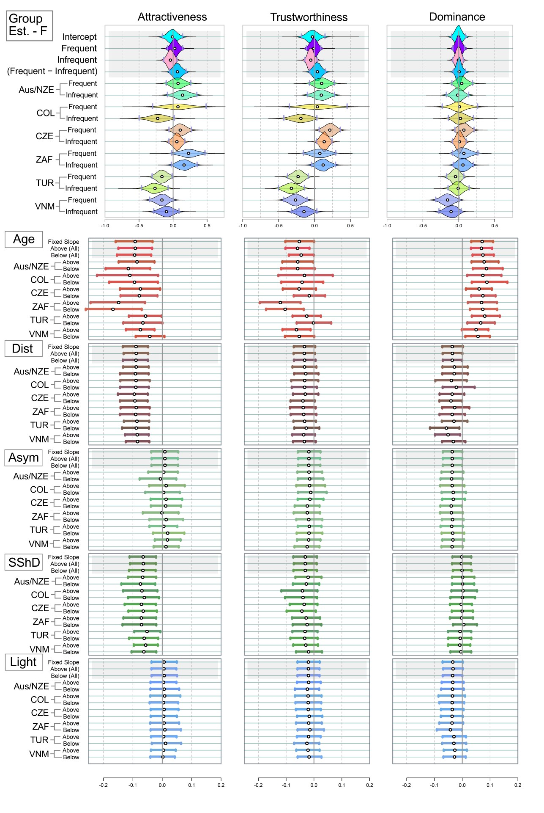

**Figure S18**. Mean estimated ratings of attractiveness, trustworthiness, and dominance in female stimuli. Analogue of Figure 3, run on models with the three dependent variables (attractiveness or trustworthiness or dominance), participants divided based on SES. White point = Mean of the estimate; Grey Vertical Bars = Border of 95% percentile-based Compatibility Intervals. Dist = distinctiveness; Asym = facial asymmetry; SShD = Sexual Shape Dimorphism; Light = Skin lightness. Group Est. = Group Estimates - average ratings assigned to the faces in the group of frequent and infrequent users per population. Like in Figures above, the country abbreviations correspond to three-letter country codes. *Version 1.*

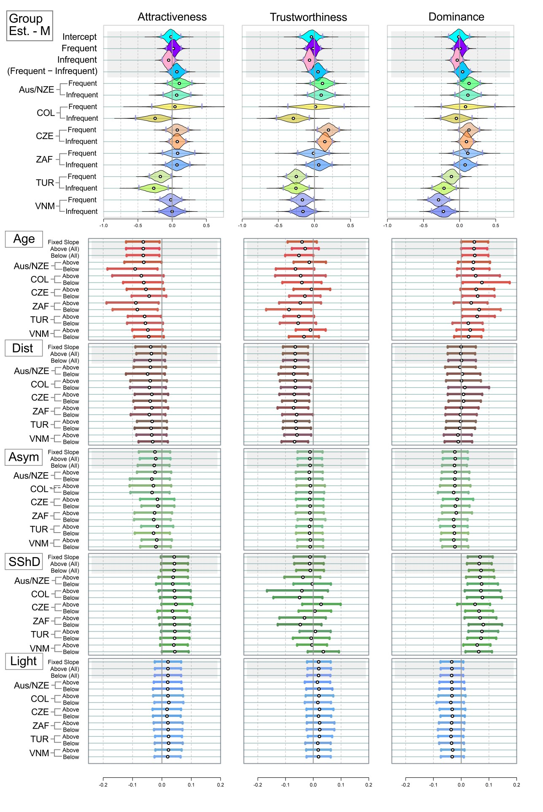

**Figure S19**. Mean estimated ratings of attractiveness, trustworthiness, and dominance in male stimuli. Analogue of Figure 3, run on models with the three dependent variables (attractiveness or trustworthiness or dominance), participants divided based on SES. *Version 1.*

|  |  |  |  |
| --- | --- | --- | --- |
| **Table S7.** Correlation comparisons. Do those, who came from high-SES families, agree better with each other? Mean stands for “Mean correlation”. Version 1. | | | |
| Female stimuli | Attractiveness | Trustworthiness | Dominance |
| Mean within cultures | **0.77 [0.70; 0.83]** | **0.66 [0.56; 0.75]** | **0.57 [0.45; 0.68]** |
| Mean across cultures | **0.66 [0.60; 0.72]** | **0.59 [0.52; 0.66]** | **0.44 [0.35; 0.52]** |
| *Difference* | ***0.11 [0.05; 0.17]*** | ***0.07 [*−*0.02; 0.15]*** | ***0.13 [0.02; 0.24]*** |
| Mean: SES Above | **0.68 [0.60; 0.76]** | **0.54 [0.44; 0.65]** | **0.54 [0.44; 0.65]** |
| Mean: SES Below | **0.64 [0.56; 0.71]** | **0.62 [0.52; 0.70]** | **0.47 [0.37; 0.58]** |
| *Difference* | ***0.04 [*−*0.06; 0.14]*** | **−*0.07 [*−*0.20; 0.05]*** | ***0.07 [*−*0.08; 0.22]*** |
| Male stimuli | Attractiveness | Trustworthiness | Dominance |
| Mean within cultures | **0.77 [0.69; 0.83]** | **0.67 [0.57; 0.76]** | **0.64 [0.54; 0.73]** |
| Mean across cultures | **0.65 [0.58; 0.71]** | **0.56 [0.48; 0.63]** | **0.49 [0.41; 0.57]** |
| *Difference* | ***0.12 [0.05; 0.18]*** | ***0.11 [0.02; 0.20]*** | ***0.15 [0.05; 0.24]*** |
| Mean: SES Above | **0.60 [0.52; 0.69]** | **0.55 [0.45; 0.65]** | **0.47 [0.36; 0.59]** |
| Mean: SES Below | **0.70 [0.62; 0.77]** | **0.57 [0.47; 0.67]** | **0.55 [0.44; 0.65]** |
| *Difference* | **−*0.09 [*−*0.20; 0.01]*** | **−*0.02 [*−*0.15; 0.10]*** | **−*0.07 [*−*0.22; 0.07]*** |

### Part 3.3. Socioeconomic status during childhood – ver. 2

Model layout is still the same, but “above/below” correspond to socioeconomic status.   
**Socioeconomic status**: participants were splitted in two groups. Participants who reported their Socioeconomic status during childhood as "Rich", "Upper CL", and “Middle” were coded as “above”, the rest of the participants is “below” (NAs and “those who do not want to respond” excluded)

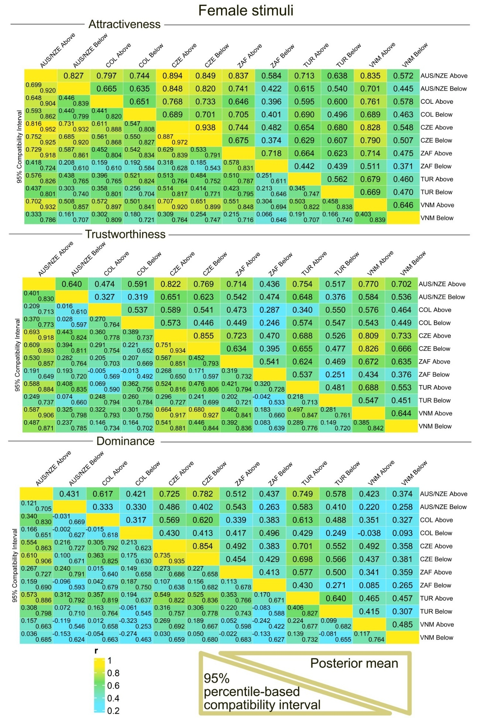

**Figure S20**. Participants from every country (the abbreviations are same as above), divided according to self-reported SES. Female stimuli. Please, mind that the numbers in some samples are low and unequal. *Version 2.*

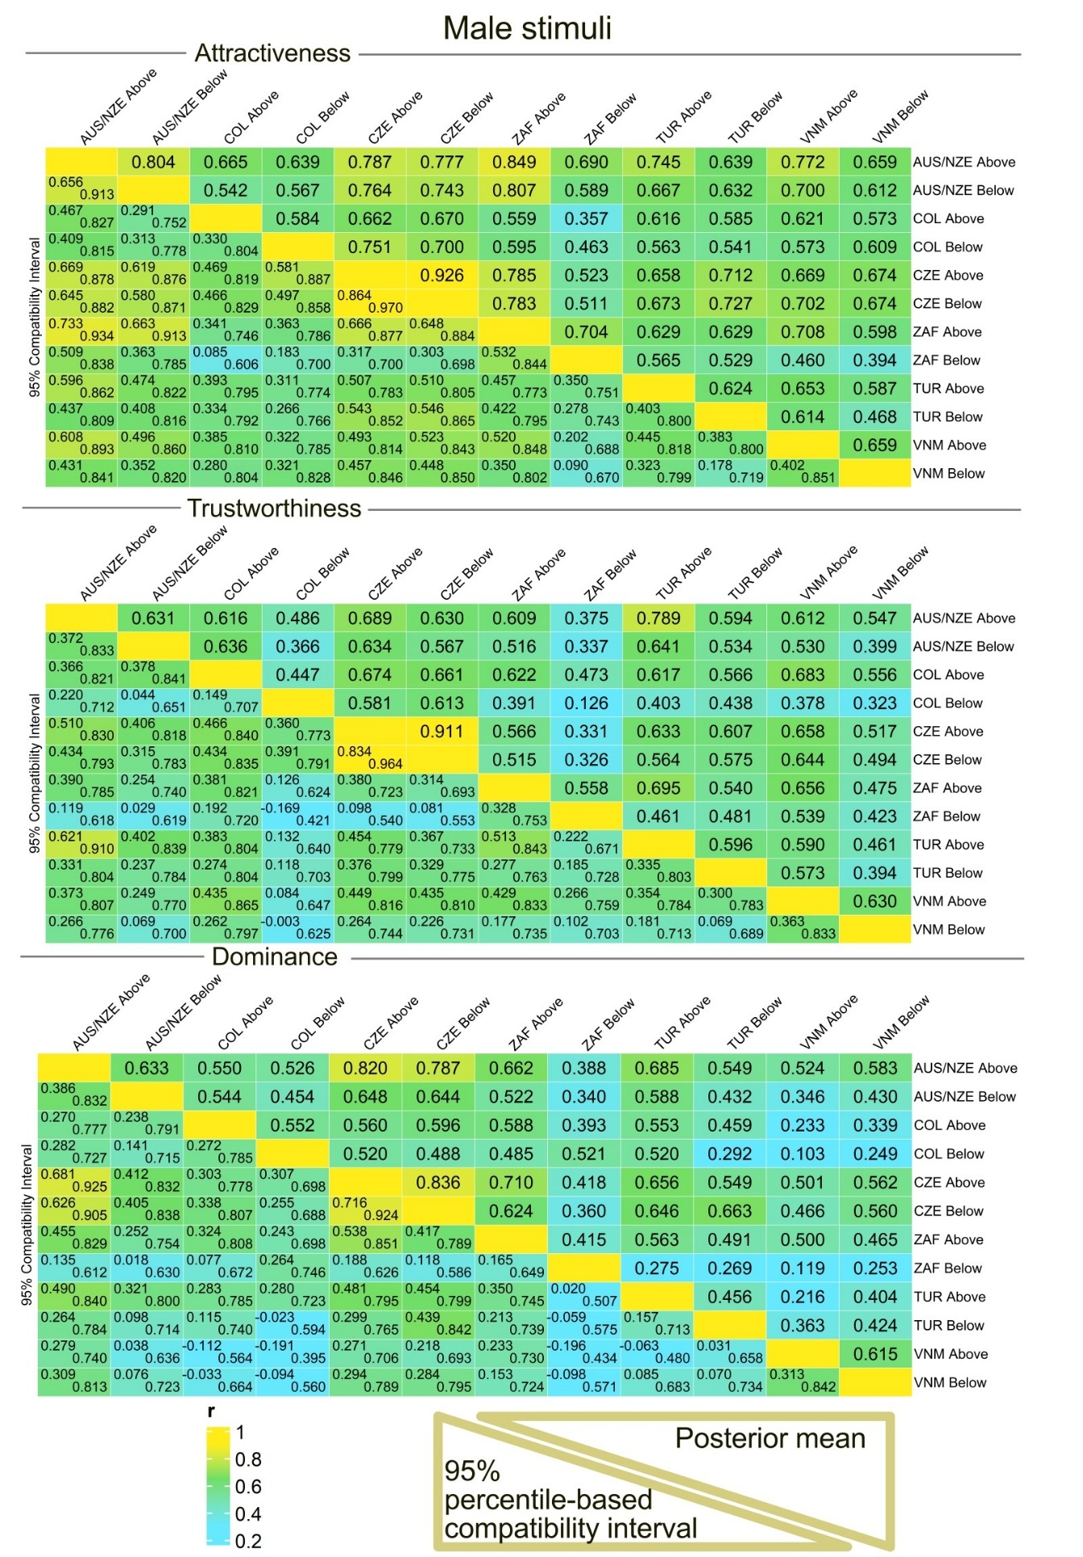

**Figure S21**. Participants from every country (the abbreviations are same as above), divided according to SES. Male stimuli. Please, mind that the numbers in some samples are low and unequal. *Version 2.*

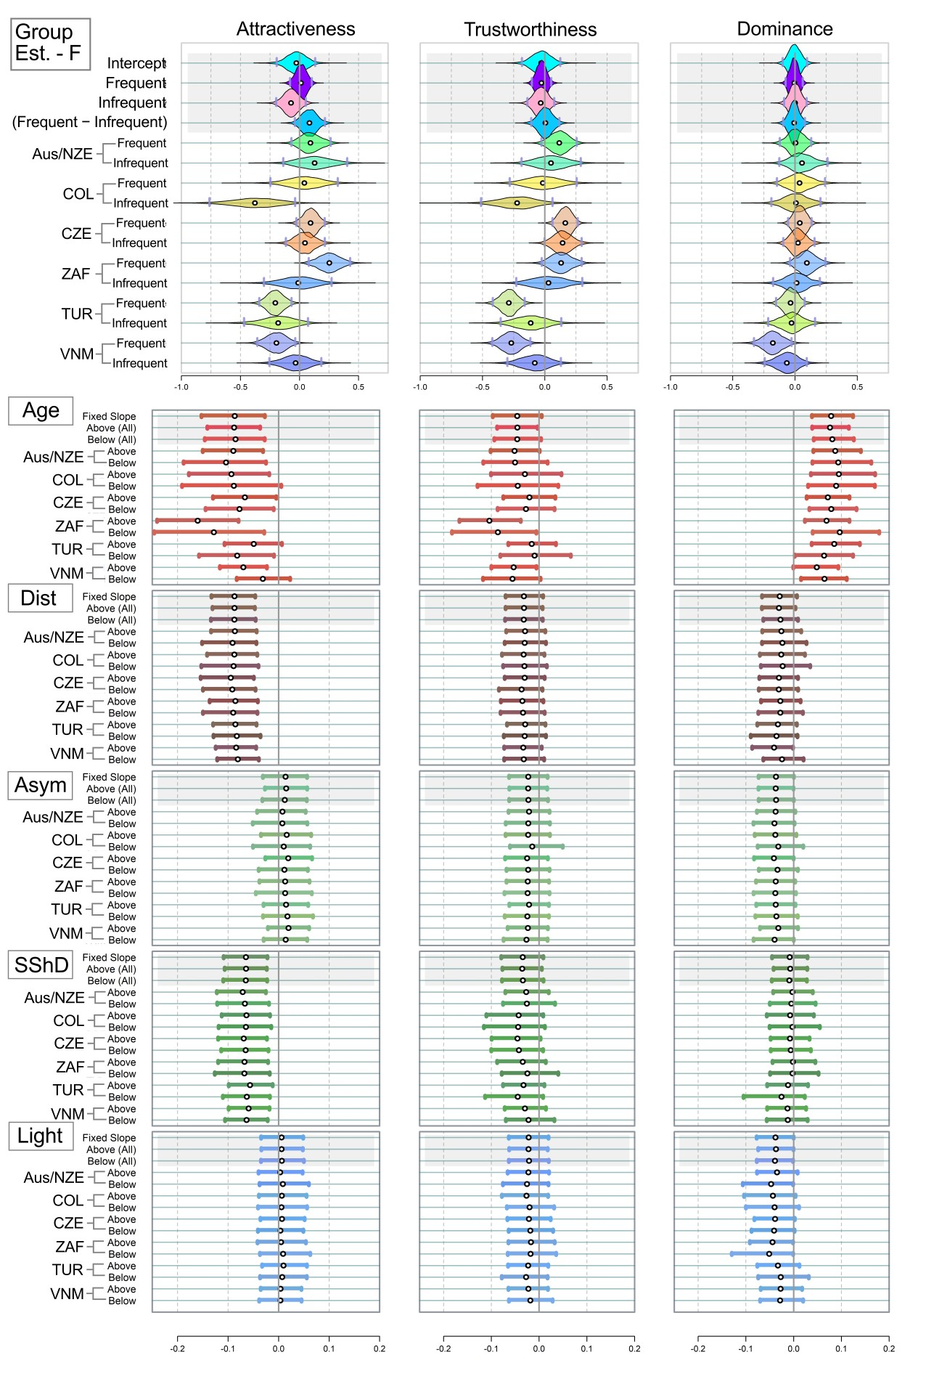

**Figure S22**. Mean estimated ratings of attractiveness, trustworthiness, and dominance in female stimuli. Analogue of Figure 3, run on models with the three dependent variables (attractiveness or trustworthiness or dominance), participants divided based on SES. White point = Mean of the estimate; Grey Vertical Bars = Border of 95% percentile-based Compatibility Intervals. Dist = distinctiveness; Asym = facial asymmetry; SShD = Sexual Shape Dimorphism; Light = Skin lightness. Group Est. = Group Estimates - average ratings assigned to the faces in the group of frequent and infrequent users per population. Like in Figures above, the country abbreviations correspond to three-letter country codes. *Version 2.*

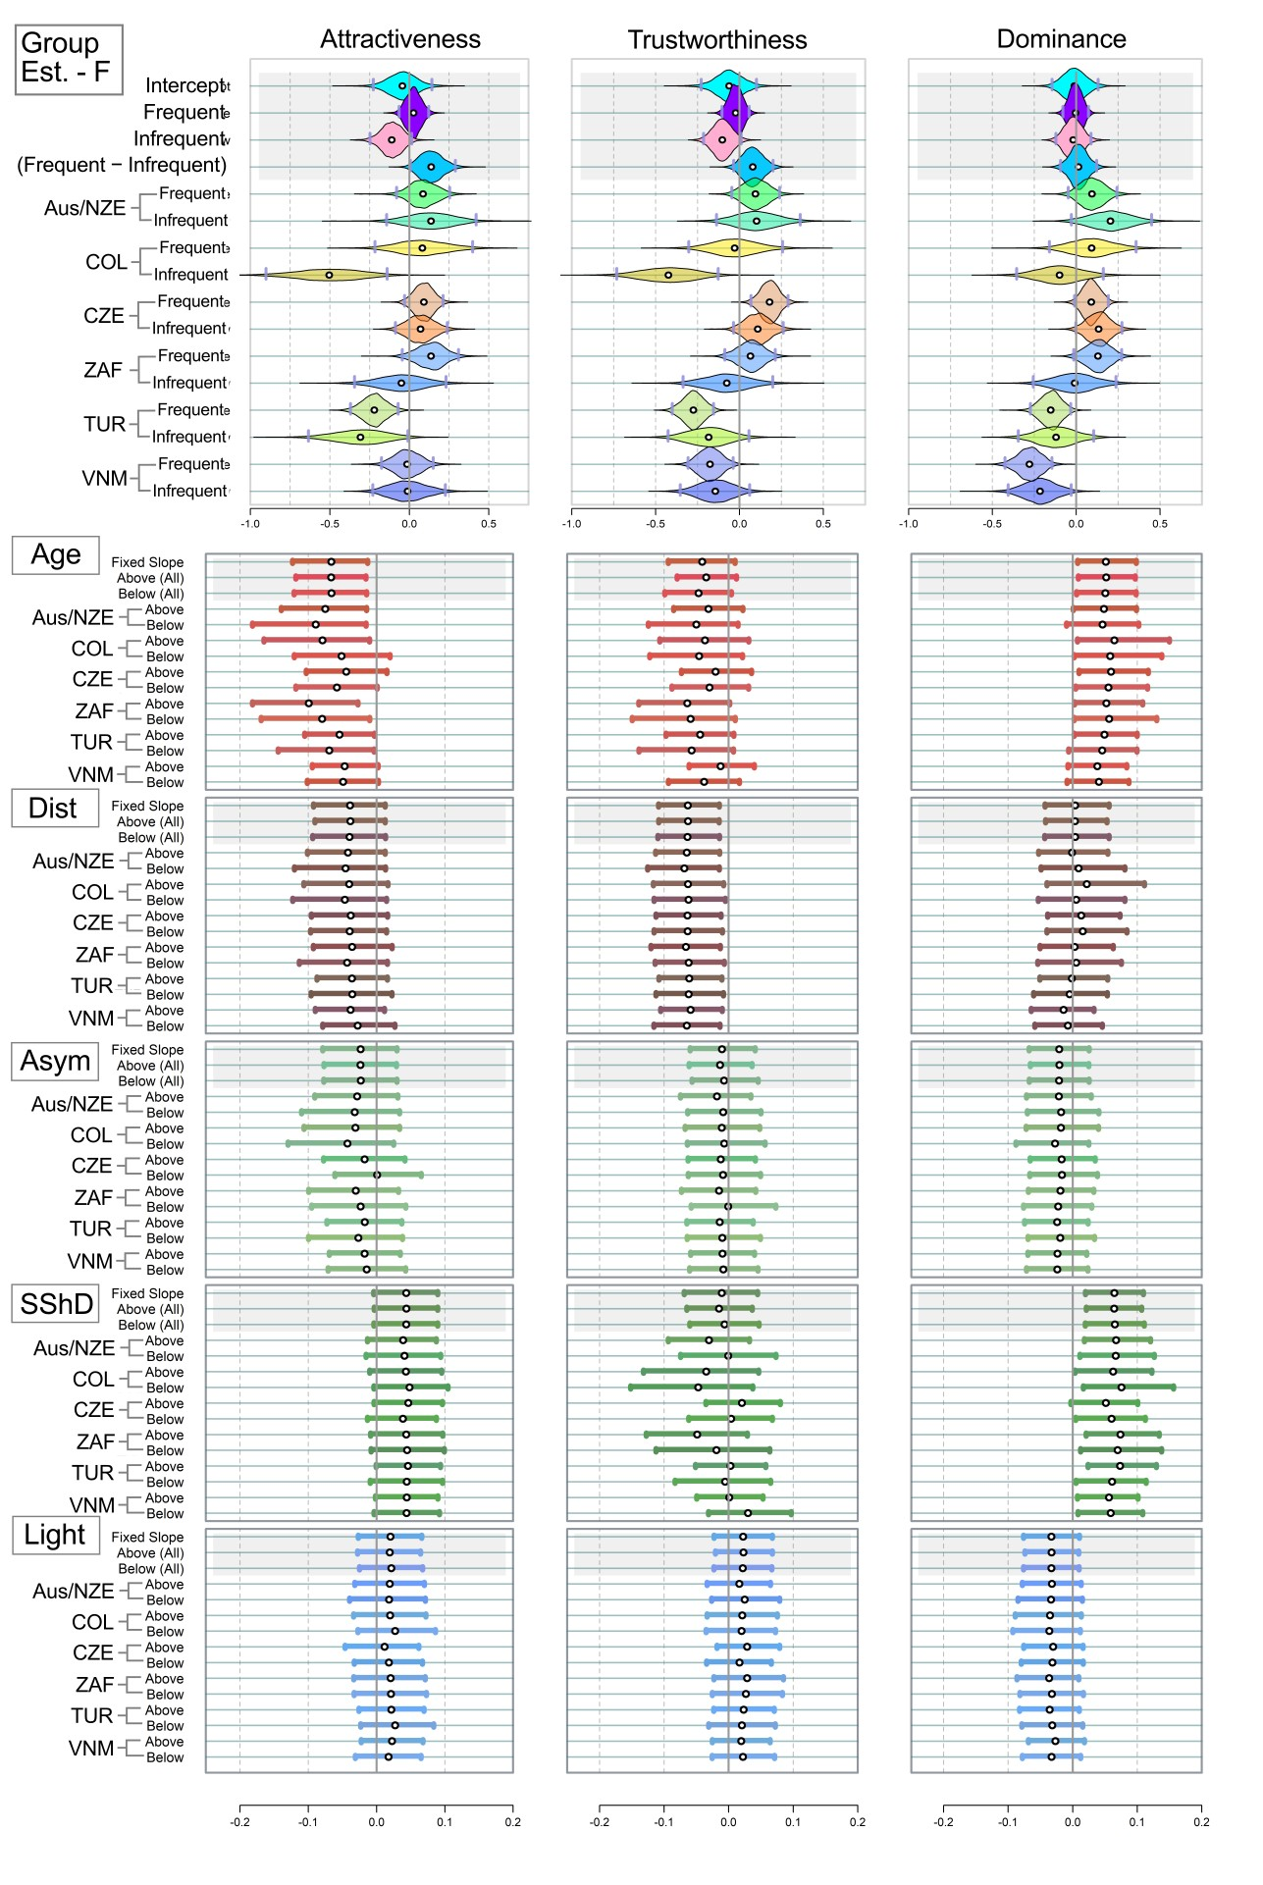

**Figure S23**. Mean estimated ratings of attractiveness, trustworthiness, and dominance in male stimuli. Analogue of Figure 3, run on models with the three dependent variables (attractiveness or trustworthiness or dominance), participants divided based on SES. *Version 2.*

|  |  |  |  |
| --- | --- | --- | --- |
| **Table S8.** Correlation comparisons. Do those, who came from higher-SES families, agree better with each other? Mean stands for “Mean correlation”. Version 1. | | | |
| Female stimuli | Attractiveness | Trustworthiness | Dominance |
| Mean within cultures | **0.72 [0.65; 0.79]** | **0.62 [0.52; 0.70]** | **0.52 [0.41; 0.63]** |
| Mean across cultures | **0.63 [0.57; 0.69]** | **0.56 [0.49; 0.63]** | **0.43 [0.35; 0.51]** |
| *Difference* | ***0.09 [0.03; 0.15]*** | ***0.06 [*−*0.02; 0.14]*** | ***0.09 [*−*0.02; 0.19]*** |
| Mean: SES Above users | **0.74 [0.67; 0.80]** | **0.65 [0.56; 0.73]** | **0.65 [0.56; 0.73]** |
| Mean: SES Below users | **0.51 [0.42; 0.60]** | **0.44 [0.34; 0.54]** | **0.34 [0.23; 0.46]** |
| *Difference* | ***0.23 [0.13; 0.33]*** | ***0.21 [0.09; 0.32]*** | ***0.30 [0.16; 0.45]*** |
| Male stimuli | Attractiveness | Trustworthiness | Dominance |
| Mean within cultures | **0.72 [0.63; 0.79]** | **0.63 [0.53; 0.72]** | **0.58 [0.48; 0.68]** |
| Mean across cultures | **0.64 [0.57; 0.70]** | **0.53 [0.45; 0.60]** | **0.48 [0.39; 0.55]** |
| *Difference* | ***0.08 [0.01; 0.15]*** | ***0.10 [0.01; 0.18]*** | ***0.11 [0.01; 0.20]*** |
| Mean: SES Above users | **0.69 [0.61; 0.76]** | **0.65 [0.56; 0.73]** | **0.55 [0.46; 0.65]** |
| Mean: SES Below users | **0.58 [0.49; 0.68]** | **0.43 [0.33; 0.53]** | **0.43 [0.31; 0.54]** |
| *Difference* | ***0.11 [*−*0.00; 0.22]*** | ***0.22 [0.10; 0.34]*** | ***0.13 [*−*0.01; 0.27]*** |

*Explanation of the large effect in Table S8*: When we put the group “Middle” to the “Above” group, the group “Below” becomes much smaller than the “Above” group.